DECLARATION OF SUBMISSION OF PROPERTY
TO HORIZONTAL PROPERTY REGIME
FOR
BRIARGATE SECOND, A CONDOMINIUM
TABLE OF CONTENTS
ARTICLE I - PURPOSES AND CERTAIN DEFINITIONS 1
- Purpose 1
- Definitions 1
ARTICLE II - DESCRIPTION OF LAND AND BUILDINGS;
PRINCIPAL MATERIALS 2
- Land
CM OJ CM CO CO CO CO CO CO CO CO CO CO ■'d"
- Building Site Plan and Site Survey
- Access
- Particulars of Units
- Principal Materials
ARTICLE III - IDENTIFICATION OF UNITS
- Location of Units
- Plans and Certificate
- identification of Units by Number
- Identification of Units Not Completed
ARTICLE IV - DESCRIPTION/DEFINITION COMMON ELEMENTS AND UNITS
- General Common Elements
- Limited Common Elements
- Units
ARTICLE V - FRACTIONAL INTEREST OF EACH UNIT IN THE
COMMON ELEMENTS; VOTING RIGHTS; UNIT FEATURES 4
- Fraction of Ownership Interest; Voting Rights 4
i
- Voting Rights 4
- Unit Features 4
- Optional Items; Permitted Variations 4
ARTICLE VI - DEVELOPER’S RESERVED RIGHTS AND POWERS 5
- Developer’s Activities and Unit Ownership 5
- Construction of Units and Reservation of Rights to Modify Units,
Construction and Variation Without Amendment of the Declaration 5
- Enlargement of Regime 5
- Assignment of Developer’s Rights 6
- Supplementary Clauses 6
- Power of Appointment 6
- Power of Appointment to Shift Fractional Interests 7
- Compliance With Horizontal Property Act 7
- Designation of Association Directors 7
- Initial Working Capital Fund 7
- Right of Access 7
ARTICLE VII - APPURTENANCES TO UNIT OWNERSHIP AND
TRANSFER; SUBDIVISION 7
- Appurtenances 7
- Assignment or Transfer of Appurtenances;
Severance ⁸
- Subdivision ⁹
- Liens ⁹
ARTICLE VIII - MANAGEMENT OF THE REGIME ⁹
- Council of Co-Owners; Membership, Vote or
Other Action of Owners ⁹
- Agreements and Compliance ⁹
- Included Powers; Foreclosure of Lien,
Waiver of Partition ⁹
- No Avoidance by Waiver of Use; Right of Entry ⁹
- Association as Attorney-in-Fact for Owners ⁹
- Subordination of Assessment Liens ⁹
- Availability of Documents and Records 10
ARTICLE IX - MAINTENANCE, ALTERATION AND IMPROVEMENTS 10
- Terms 10
- Maintenance by Association 1⁹
- Maintenance by Owner 1
- Responsibility of Owner; Insurance Proceeds 11
- Maintenance Involving More Than One Unit 11
- Alteration or Improvements by Unit Owner 11
- Alteration or Improvement by the Association
or All Owners 1
12
12
12
12
13
13
13
13
13
13
13
14
14
14
14
14
14
15
15
15
15
15
16
16
16
17
17
17
17
17
17
17
17
17
.17
.17
.17
.18
ARTICLE X - CONDITIONS OF AND RESTRICTIONS ON
OWNERSHIP, USE AND ENJOYMENT
- Underlying Conveyance/Mortgage/Lease
- Exterior Facade
- Activity Affecting Insurance
- Keys
- Pets/Refuse/Compliance
- Storage
- Repair, Maintenance and Reconstruction
- Liens
- Additional Rules, Restrictions and Regulations
- Use of Unit/Leases/Liability
- Enforcement Penalties and Fines
- No Waiver
ARTICLE XI - DESTRUCTION; CASUALTY AND REPAIRS
- Damage to Less Than One-Half of Units
- Underinsured
- Substantial Damage to One-Half or More of Units
- Substantial Loss Restrictions
ARTICLE XII - RECONSTRUCTION OR REPAIR OF CASUALTY DAMAGE
- Responsibility
- Caliber of Work
- Payment of Costs
ARTICLE XIII - AMENDMENT
- Procedure
- Effectiveness
- Ownership Units
ARTICLE XIV - EFFECTIVE DATE; POSSESSION OF COMMON
ELEMENTS; CONDEMNATION AND OBSOLESCENCE; PARTITION; SEVERABILITY; ARTICLES OF INCORPORATION AND BYLAWS OF ASSOCIATION; CHAPTER 504, CODE OF IOWA ¹ ²
ARTICLE XVI - INSURANCE AND FIDELITY BONDS 18
- Condominium Property Insurance 18
- Premiums, Deductibles and Minimum Coverage 20
- Adjust Losses 20
- Contribution 20
- Additional Insurance 20
- Cancellation or Modification 20
- Designation 20
- Insurance Trustee Responsibilities 20
- Policy Requirements 20
- Blanket Fidelity Bonds 22
ARTICLE XVII - CONDEMNATION 23
- Taking by Eminent Domain 23
EXHIBITS:
A Building Site Plan
B-1 Site Survey
B-2 Site Survey
B-3 Site Survey
D-1 Complete Set of Plans
D-2 Complete Set of Plans
D-3 Complete Set of Plans
E Certificate of Engineer
F Principal Materials
G Fractional Interest and Approximate Area
H Articles of Incorporation of Briargate Second Owners Association, Inc.
I Bylaws of Briargate Second Owners
Association, Inc.
F:\WP\MISC\ptieasant ridge dev - briargate 2nd\bnargate 2nd toe. DOC
THIS INSTRUMENT PREPARED BY: STEPHEN C. NELSON
Moyer & Bergman, PLC, 2720 1st Ave. NE, PO Box 1943, Cedar Rapids, IA 52406-1943, (319) 366-7331
DECLARATION OF SUBMISSION OF PROPERTY
TO HORIZONTAL PROPERTY REGIME
FOR
BRIARGATE SECOND. A CONDOMINIUM
The undersigned, PHEASANT RIDGE DEVELOPMENT, L.L.C., an Iowa limited liability company with its principal place of business in Cedar Rapids, Iowa, (the “Developer) executes this instrument of declaration of submission of property to a horizontal property regime (the “Declaration”) to be known as Briargate Second, a Condominium (the “Condominium”), all pursuant to Chapter 499B, Code of Iowa, entitled Horizontal Property Act (Condominiums), to take effect when filed for record in the office of the Linn County Recorder.

ARTICLE I

PURPOSES AND CERTAIN DEFINITIONS
- Purpose. The purpose of this Declaration is to submit and convey the lands described in this Declaration and the buildings and other improvements constructed or to be constructed on the land to the condominium form of ownerships and use pursuant to Iowa law. Developer is constructing three Buildings with one Building containing Unit 4420 Saratoga Court, Unit 4422 Saratoga Court, Unit 4426 Saratoga Court and Unit 4428 Saratoga Court; the second Building containing Unit 4402 Saratoga Court, Unit 4404 Saratoga Court and Unit 4406 Saratoga Court; and the third Building containing Unit 4392 Saratoga Drive, Unit 4394 Saratoga Drive, Unit 4396 Saratoga Drive and Unit 4398 Saratoga Drive, Marion, Iowa, with each of the Units having an attached 1-car or 2-car garage, all in accordance with the terms of this Declaration. Developer reserves the right to add additional land and to construct additional Units but shall not be required to do so.
- Definitions. The terms employed shall have the meanings given them in Chapter 499B, Code of Iowa, unless the context or the more particular provisions of any condominium document requires a different one. Certain terms are used as follows;
- Plural and Gender. AH words or phrases shall be taken to include the singular or plural according to context and to include the female, male or neuter gender as may be applicable.
- Successors. Reference to Developer, owner, or to any entity or association shall include the respective successors, grantees and assigns.
- Tense. Upon the effective date of this Declaration, use of the present tense shall include the future tense and use of the future tense shall include the past or present tense as may be applicable, particularly where the subject matter relates
1

to completion of an improvement that has not been or already has been completed as the case may be.
- Unit. A Unit means generally an area defined by surfaces or planes which is capable of being owned as a separate parcel of real property under the Iowa Horizontal Property Act, which includes but is not limited to, the living areas. This Declaration initially defines seven Units that are capable of being owned as separate parcels of real estate and will include other Units if and when added to this Declaration by amendment.
- Proposed Units. Proposed Units are Units which have not been identified and defined by this Declaration or amendments to this Declaration. The Developer may, from time to time, file amendments to this Declaration to identify, define and add the Proposed Units as Units.
- Building. A Building shall refer to any structure containing one or more Units and which may also contain garage stalls and which is constructed on the land submitted to the horizontal property regime.
- Condominium Documents and Property. This Declaration and all attached exhibits, and supplements and amendments constitute the condominium documents. The terms “condominium property" or “the property” include all property, real, personal or mixed, including such as are sometimes referred to as “facilities” submitted now or later to the regime, or owned by the Association if context requires, other than the sole personal property of Developer or any owner.
- Garage. Each garage shall include and be a part of the Unit identified on the attached Exhibits.
- Briargate Second Owners Association. Inc. A non-profit corporation organized under Chapter 504 of the Code of Iowa to serve as the council of the owners of the Units submitted to this regime (the “Association”).
0) Bylaws. The Bylaws of the Association.

ARTICLE II
DESCRIPTION OF LAND AND BUILDINGS; PRINCIPAL MATERIALS
1. Land. The land conveyed and submitted to the Horizontal Property Regime is situated in Marion, Linn County, Iowa, and is legally described as follows:
Lots 1, 2 and 3, Briargate Second Addition in the City of Marion,
Linn County, Iowa, (the “land”).
- Building Site Plan and Site Survey. Attached as Exhibit A is the Building Site Plan which shows the existing Building and the proposed location of the Building that the Developer may construct on the land. Attached as Exhibits B-1, B-2 and B-3 are the Site Surveys which show the location and dimensions of the three Buildings.
- Access. Exhibit A shows the location of 44th Street, Marion, Linn County, Iowa which is a public street and provides ingress and egress to the private drives serving each of the Buildings.
- Particulars of Units. Exhibits D-1, D-2 and D-3 show a complete set of plans for the three Buildings which are to be included in the Regime. The Units in the three Buildings each have one or two stories and an attached 1-car or 2-car garage which is located on the first level and is accessible directly from the Unit. The approximate area of each Unit is set forth on Exhibit G. Each Unit has a deck or patio.
- Principal Materials. The principal materials for each Unit are shown on Exhibit F.
ARTICLE III
IDENTIFICATION OF UNITS
- Location of Units. The location of the Units, the rooms, the dimensions of the Units, and the common area to which the Units have access are all shown and depicted on Exhibits A, B-1, B-2, B-3, D-1, D-2 and D-3.
- Plans and Certificate. Exhibits D-1, D-2 and D-3 are full and exact copies of the complete plans of the three Buildings which is submitted pursuant to Section 499B.6 of the Code of Iowa. A Surveyor’s Certificate is attached as Exhibit E.
- Identification of Units bv Number. Each Unit is identified by its street address as set forth on Exhibit B-1, B-2, B-3 and Exhibit G. In addition, the Unit number of each Unit and its approximate area is set forth on Exhibit G. Exhibit G sets forth the fractional interest of undivided ownership in the land and other common elements in the regime for each Unit.
- Identification of Units Not Completed. Developer reserves the right to amend this Declaration to add proposed Units, to add additional floor plans, to change floor plans of Units and to make other modifications as set forth in Article VI.

ARTICLE IV

DESCRIPTION/DEFINITION OF COMMON ELEMENTS
AND UNITS
The condominium regime consists of Units that are separate parcels of real estate individually owned and of common property (“common elements") that may be used by the Unit owners. The common elements are either “general common elements” or “limited common elements”.
- General Common Elements. The general common elements are the land and all improvements, devices and installations existing for the common use, except the Units and such common elements as are specifically defined as limited common elements. The general common elements include, without being limited thereto, (i) the land, the structural elements of each Building, private drives, paths, landscaping, plantings, sidewalks, gutters, downspouts and all personal property required by the Association for its functions as the council of co-owners, all outside parking areas, common lighting system and common water system and meter, if any, (ii) all outside lighting systems and fixtures that are not reserved as a limited common element for the use of a specific Unit and (iii) all devices or installations existing for common use.
All general sewer, water, electrical, gas, telephone and other utility or service lines that are not reserved for the use of a particular Unit are general common elements. The general common elements shall include easements to Units for all such lines, wiring, ducts and the like above referred to for the furnishing of utility and other services or systems to the other Units and to the common property and easements of support in every portion of a Unit which contributes to the support of the improvements.
- Limited Common Elements. The limited common elements include such common property that is classified and defined by Section 499B.2(5), Code of Iowa. The limited common elements include such common property that is reserved for the use of a particular Unit to the exclusion of other Units. The common property that is specified and determined to constitute a limited common element for the use of a Unit includes, but is not limited to, (i) all of the internal structural and non-structural elements of a Unit, including the foundations, basements (if any), floors, interior walls, ceilings, roofs, stairways, decks, if any, patios (if any), doors and windows, including any sliding glass door of a particular Unit, (ii) all fixtures, attachments, machines, equipment, utility lines, service lines, driveways, sidewalks and outside lighting systems and fixtures that pertain to the use of a particular Unit, (iii) the garage door for each Unit, and (iv) the mailbox with a number that corresponds to the Unit number.
- Units. Each Unit shall consist of the area between the interior surfaces of its perimeter walls (including windows and sliding doors or windows, and including the interior surface of the exterior door(s)), and between the lower surface of the ceiling and the upper surface of the concrete slab or the floor. In all cases, a Unit shall include and be defined by the surfaces referred to and shall include any non-load bearing partitions within, except that all lines, wires, ducts and other services used by more than one Unit within any non- load bearing partition or wall shall be excluded and shall not constitute a part of the Unit for purposes of separate ownership of such Unit. Each Unit shall include the Garage that is accessible from the interior of the Unit. Each Garage shall consist of the area between the interior surfaces of its perimeter walls (including the garage door) and between the lower surface of the ceiling and the upper surface of the concrete slab.

ARTICLE V

FRACTIONAL INTEREST OF EACH UNIT IN THE
COMMON ELEMENTS: VOTING RIGHTS: UNIT FEATURES
- Fraction of Ownership Interest: Voting Rights. The owner of each Unit shall own as an appurtenance an undivided interest in the land and other common elements of the regime, both limited and general. Such interest shall be the same in both the limited common elements and the general common elements, notwithstanding any exclusive right of use of any limited common element which may be appurtenant to a particular Unit. The fraction of ownership interest appurtenant to each Unit is set forth in attached Exhibit G.
The fractional interest may be changed as provided in Article VI (3).
- Voting Rights. The initial total number of votes outstanding and entitled to be cast by the owners is twelve, which is equal to the initial number of Units. The owner or owners (collectively) of each Unit, as such and as an Association member (if applicable) shall be entitled to cast one vote for each Unit. The number of Units may be increased as provided in Article VI.
- Unit Features. The Developer will provide for the Unit as constructed a refrigerator, range, dishwasher, furnace, air conditioning unit, compressor for the air conditioning (it may not be located within the Unit), kitchen cabinets and tops, vanities and tops, fiberglass tub recess, interior doors, water heater, light fixtures, carpeting or other floor covering, paint or other wall covering and a garbage disposal. Developer will provide separate meters for electricity, gas and water for each Unit. The other particulars of the Units and floor plans are shown on all Exhibits with a D as a prefix and are summarized as follows: generally, each Unit has two bedrooms or three bedrooms, a living room, dining room, kitchen, one or two full baths, laundry room, closets, stairways, an unfinished daylight basement a one-stall or two-stall Garage. The items listed in this paragraph 3 and the following paragraph 4 are referenced solely for the purpose of clarifying the extent of the Developer’s undertaking and all such items shall constitute common elements, a part of the Unit or personal property of the owner of the Unit as provided in this Declaration.
- Optional Items: Permitted Variations. Various optional items may be provided by Developer during construction by arrangement with and extra cost to the purchaser of a Unit. Certain of the items provided by the Developer in the previous paragraph 3 may be deleted or items of different character may be substituted by the Developer or by the purchaser of the Unit. The Developer and Unit owner may by written agreement delete, relocate, modify or add interior non-load bearing partitions. The addition of any optional items or the deletion, relocation, modification or additions described in this paragraph shall not be construed to constitute an amendment to or variation from the terms of this Declaration and shall not vary or modify the fraction of ownership interest appurtenant to such Unit.

ARTICLE VI

DEVELOPER'S RESERVED RIGHTS AND POWERS
- Developer's Activities and Unit Ownership. Developer is irrevocably and perpetually empowered, notwithstanding any use restriction or other provision of the condominium documents to the contrary, to sell, lease, or rent Units without restriction of any kind. Developer shall have the right to transact on the condominium property any business relating to construction, sale, lease or rental of Units, including, but not limited to, the right to maintain models, offices, signs, employees and equipment and materials on the premises and to use common elements to show Units. A sales and rental office, signs and all items and equipment pertaining to sales or rentals or other facilities furnished by the Developer shall not be considered common elements and shall remain its separate property. Until Developer conveys title, Developer shall be and remain the owner of all Units, all under the same terms and conditions as other owners including membership in the Association save for this right to sell, rent, or lease. Units that have not been built shall not be subject to assessment. Units that have been built and are owned by the Developer shall only be subject to assessment and lien for “current expenses” of the Association as distinguished from assessments for “reserves” or “emergencies” as referred to in the Bylaws, and furthermore Developer shall have the option of either paying such current expense assessment on unsold Units, or, in lieu thereof, to make up any deficiencies existing in the current operational and maintenance expenses of the regime. If Developer makes up such deficiencies, the lien of any assessments against its Units shall be automatically discharged but the Association upon request shall satisfy or release such lien in writing.
- Construction of Units and Reservation of Rights to Modify Units.
Construction and Variation without Amendment of the Declaration. The construction of Units shall be in accordance with the terms of this Declaration and the plans and attached exhibits, except Developer reserves the right on its own initiative or pursuant to agreement with the purchaser of a particular Unit, or at the request of mortgagees, any insurance carrier, the architect, or the public authorities to make or authorize variations or adjustments of an insubstantial character that are not meaningfully prejudicial to the rights of owners and do not materially affect such rights or the value of a Unit, which variations or adjustments are permitted without the necessity of consent by other owners and shall not constitute an amendment of this Declaration. Variations which do materially affect such rights or value shall be limited to a change in the location of the Buildings of a reduction by more than ten percent (10%) in size, physical layout or design of a Unit, except that slight deviations required by construction or arising from the installation of the walls and/or partitions, changes in the location or design of a non-load bearing partition, closet or other feature within a Unit, and slight variations in the location of the Unit which an accurate survey would show are permitted and the right to make the same reserved by Developer. Notwithstanding the foregoing, Developer shall not have any obligation to construct any additional Units or improvements to be added to this regime.
- Enlargement of Regime. Notwithstanding any provision to the contrary contained in this Declaration, the Developer may enlarge the regime by submitting additional Buildings as follows:
- To enlarge the regime pursuant to this section, Developer must file in the office of the Recorder of Linn County, Iowa, no later than seven (7) years from the date of filing of this Declaration of Submission of Property to Horizontal Property Regime (the “Declaration”), an amendment to this Declaration that shall describe the Buildings to be added to the regime. The amendment shall contain whatever exhibits are necessary to fully describe the Buildings.
- An amendment filed pursuant to this Article shall be effective with respect to and shall apply to the added Buildings as if the Buildings were initially submitted to the regime.
- If proposed Units are submitted to the regime, upon the recording of the amendment submitting the proposed Units, the fractional interest in common elements appurtenant to all Units shall be adjusted to include the added Units.
The total fractional interest appurtenant to all Units shall be equal to one (1), and every Unit shall have an equal fractional interest. The Developer shall include as part of such amendment an Exhibit to show the fractional interests of Units as revised by such amendment.
- Developer is not restricted as to the number of times the regime may be enlarged by submitting additional Buildings.
- An amendment filed pursuant to this section shall be effective when executed by the Developer and filed in the office of the Recorder of Linn County, Iowa. The consent of owners of Units and their mortgagees is not required, and amendments pursuant to this section shall be effective notwithstanding the objection, if any, of the owners of Units.
- The Proposed Units shall be of a quality, type of construction and general character equal or superior to and compatible with the existing Units.
- If HUD, the VA or FNMA holds, insures or guarantees any mortgage on existing Units at the time the Developer desires to proceed with any expansion of the condominium regime as provided in this paragraph 3, each such agency or entity must give its written consent to the particular phase of expansion. Provided, however, such consent shall not be withheld if the proposed expansion substantially conforms to the plan of expansion set forth in this paragraph 3.
- The Buildings to be included in the enlargement and appurtenant improvements must be substantially completed before the Proposed Units can be added to the condominium regime by the filing of an amendment to the Declaration. All taxes and other assessments relating to the property in the enlargement covering any period prior to the addition of the Proposed Units must be paid or otherwise satisfactorily provided for by the Developer prior to filing the amendment to the Declaration to include the Proposed Units. If FNMA holds any mortgage on an existing Unit at the time any additional Land is added to the condominium regime, FNMA must be furnished with title evidence in a form satisfactory to it, which discloses any lien, easement or other encumbrance affecting the additional Land to be added which will affect the existing condominium regime after such addition. All of the original cost of any land, or the Buildings, Units, and other improvements existing or to be constructed, which are added to the condominium regime, shall be paid for by Developer and no part of the cost shall ever be assessed against any Units as a common expense. The Association shall provide the mail boxes for the Units.
- Assignment of Developer’s Rights. Developer may assign all of its rights and powers under this Declaration, in whole or in part, without the consent of the Association, Unit owners and mortgagees.
- Supplementary Clauses. Various provisions of this Declaration, and deeds and mortgages of the Units and common elements, contain clauses designed to accomplish shifting of the common elements as the regime is expanded by the addition of land and Units. None of those provisions shall invalidate the other, but each shall be deemed supplementary to the other toward the end that a valid shifting of the common elements can be accomplished.
- Power of Appointment. Each deed of a Unit shall be deemed to reserve to the Developer the power to appoint to Unit owners, from time to time, the fractions in the common elements set forth in amendments of the Declaration that expand the regime by the addition of Units.
7. Power of Appointment to Shift Fractional Interests. A power coupled with an interest is hereby granted to Jeffery Witter or to Sarah Witter or to any person acting as president or secretary of Developer as attorney-in-fact to shift fractional interests of the common elements in accordance with amendments to the Declaration recorded pursuant to this section which expand the regime by the addition of Units, and each deed of a Unit and common elements in the regime shall be deemed a grant of such power to said attorney-in- fact.
- Compliance With Horizontal Property Act. Each Unit owner, by acceptance of the deed conveying a Unit, agrees for such owner and all those claiming under such owner, including mortgagees, that this Declaration is in accordance with the Horizontal Property Act.
- Designation of Association Directors. Developer shall have the right to name all members of the Board of Directors of the Association until the first annual members’ meeting of the Association which shall be held no later than the earlier of 120 days after the date by which 75% of the Units (after completion of all of the Proposed Units of the condominium regime) have been conveyed to Unit purchaser or the date 5 years after the date the first Unit is conveyed (the “Control Transfer Date”). Thereafter the Board of Directors shall be selected in the manner specified in the Bylaws of the Association.
- Initial Working Capital Fund. If or when any first mortgage on a Unit is to be insured by FHA or sold to FNMA, the Developer shall establish a working capital fund in an amount at least equal to two months of the estimated common charges for each Unit then existing or being constructed in the development of the condominium regime, to meet unforeseen expenditures or to purchase additional equipment or services. The share of each Unit of the working capital fund shall be collected at the time of the sale of the Unit or on the Control Transfer Date, whichever is earlier, or for Units sold prior to the establishment of the fund, at the time of the closing of the first Mortgage loan to be insured by FHA or sold to FNMA. As any Proposed Units are completed, the Developer shall add to the fund the share for such Units at the time of the sale of each Unit or on the Control Transfer Date, whichever is earlier. Amounts paid into this fund shall not be considered as advance payments of regular assessments. The working capital fund shall be transferred by the Developer to the Association for deposit to a segregated fund on the Control Transfer Date. The Developer may not use the working capital fund to defray any of its expenses, reserve contributions or to make up any budget deficits while it is in control of the Association. The Developer may, however, reimburse itself for funds paid to the Association for any unsold Unit’s share of the working capital fund from funds collected at closing when the Unit is sold. After control of the Association has effectively been transferred to the Unit owners, the Association may determine how and when such fund shall be used for other purposes if not needed for the purposes for which it was established.
- Right of Access. The Developer reserves an easement over the common elements of the condominium regime for the purpose of completing the improvements and Proposed Units contemplated by this Declaration. Provided, however, the Developer shall restore any common element disturbed by Developer’s use of such easement to the condition existing prior to the disturbance as soon as practically feasible after Developer’s use of these easements are concluded. Also, the easement rights shall be exercised by the Developer only if and when the access required by Developer is not otherwise reasonably available other than over, across or through the common elements.

ARTICLE VII

APPURTENANCES TO UNIT OWNERSHIP AND
TRANSFER; SUBDIVISION
- Appurtenances. The ownership of each Unit shall include all of the appurtenances, including, but not limited to, the following;
- Fractional Interest of Ownership of Common Elements and Funds: Liabilities for Expenses. There shall be appurtenant to each Unit and the ownership thereof an undivided fractional interest of ownership in or liability for (1) the general common elements, (2) the limited common elements, (3) the funds and surplus, if any, of the Association, and (4) except as otherwise specifically provided in this Declaration, the common expenses and liabilities of the Association. Such undivided fractional interest of ownership or liability shall be identical as to each of the preceding four aspects, and the amount of such fractional interest or liability shall be the fraction (as may be adjusted as provided in this Declaration) fixed pursuant to Article V as set forth in Exhibit G.
- Encroachment Easements. If any portion of the common elements encroaches upon any Unit or any other portion of the common elements, or if any Unit encroaches upon any other Unit or upon any portion of the common elements upon completion of construction, or if any of such encroachments shall occur thereafter as a result of shifting or settling of a Building or from alteration, repair or improvement to the common elements and/or as a result of repair or restoration of the common elements or a Unit after damage by fire or other casualty, or as a result of condemnation or eminent domain proceedings, then in each of such events a valid easement shall exist for such encroachment and for the maintenance thereof so long as the Buildings, common elements and Units exist.
- Cross Easements. The appurtenances shall include, so long as the Buildings, common elements and Units exist, easements from each Unit owner to each other Unit owner and to the Association and from the Association to the respective Unit owners as required as follows:
- Ingress. Egress and Maintenance. Easements are reserved for ingress and egress through the common areas for access to the Units and through the common areas and the Units for purposes of maintenance, repair, replacement or reconstruction of each as authorized;
- Support. Every portion of a Unit contributing to the support of a Building is burdened with an easement of support for the benefit of all other Units and common elements in or of the building; and
- Utilities and Other Services. Easements are reserved through the Units and common elements for conduits, ducts, plumbing, wiring, piping and other facilities for the furnishing of utility or other services and facilities to the other Units and common areas, provided such easements through a Unit shall be only according to the plans and specifications for a Building as and if varied during construction as permitted in this Declaration unless otherwise agreed by the Unit owner.
- Possession and Use of Unit. Including Air Space. In addition to the fee simple ownership of a Unit, there shall be as an appurtenance an exclusive easement for the possession and use of the air or room space within the Unit and to the limited common elements of that Unit as the same exists from time to time or as altered or reconstructed from time to time subject to necessary and authorized easements for maintenance, repair and the like; which appurtenance shall be terminated automatically in the event of termination of the regime.
2. Assignment or Transfer of Appurtenances; Severance. The ownership of each Unit shall include and there shall pass and be transferred in the event of any transfer of ownership of such Unit as a parcel of realty or of any owner’s right, title or interest in the Unit, whether by deed, mortgage, other instrument or otherwise than by an instrument, all of the appurtenances whether enumerated and separately described or not; and no part of the appurtenant interest of any Unit may be sold, transferred or otherwise disposed of except in connection with the sale, transfer or other distribution of the Unit itself or all Units in the regime.
- Subdivision. No Unit shall be subdivided.
- Liens. Taxes, assessments, judgments and any other matter against a Unit owner which may give rise to a lien shall be a lien only against the Unit owner’s Unit and not against any other Unit or the common elements.

ARTICLE VIII

MANAGEMENT OF THE REGIME
- Council of Co-Owners; Membership, Vote or Other Action of Owners. The business and affairs of the regime shall be governed and managed by the Association, a non-profit membership corporation organized and existing under Chapter 504A of the Code of Iowa, which corporation is and shall constitute the council of the co-owners of the Units and common elements submitted to the regime, all as provided by Section 499 B.2(3) of the Code of Iowa. Copies of its Articles of Incorporation and its Bylaws are attached as Exhibits H and I. All owners of Units shall automatically be members of the Association, and membership in the Association shall automatically cease upon termination of such ownership interest. Whenever a vote or other action of owners as a group is required, the mechanics of conducting such a vote or taking such action shall be under the control and supervision of the Association and the Bylaws.
- Agreements and Compliance. All owners, tenants, families, guests and other persons using or occupying a Unit shall be bound by and strictly comply with the provisions of the Bylaws of the Association and the applicable provisions of the other condominium documents, and all rules and regulations and all agreements and determinations lawfully made by the Association and its directors, officers, or agents shall be binding on all such owners and other persons. A failure to comply with the Bylaws or the provisions of the other condominium documents or any agreements or determination thus lawfully made shall be grounds for an action to recover sums due for damages on the part of the Association or any owner as applicable and for mandatory or other injunctive relief, and the election of one such remedy shall not constitute the waiver of any other.
- Included Powers: Foreclosure of Lien. Waiver of Partition. Each owner agrees that the Association has and shall exercise all powers, rights, and authority granted unto it by Chapters 504A and 499B of the Code of Iowa, and such as are more particularly set forth in the condominium documents, including the making of assessments chargeable to owners and a lien on a Unit for any common expenses, and the right to foreclose the lien on a Unit and acquire a Unit at foreclosure sale and to hold, lease, mortgage or convey the same, but such acquisition shall be on behalf of all Unit owners, all of whom, however, shall be deemed to have waived all rights of partition with respect to the Unit.
- No Avoidance bv Waiver of Use: Right of Entry. The liability of an owner for all assessments made by the Association may not be avoided by waiver of the use or enjoyment of any common elements, or by abandonment of a Unit for which an assessment is made. Except in the event of an emergency, the Association shall have the right exercisable at reasonable hours to enter a Unit as may be necessary or advisable to exercise its rights or responsibilities. In the event of an emergency the Association shall have the right to enter a Unit at any time as may be necessary or advisable to exercise its rights or responsibilities.
- Association as Attornev-in-Fact for Owners. The Association is irrevocably appointed attorney-in-fact for the Owners of each and every Unit to manage, control and deal with the interest of such Owners in the common elements so as to permit the Association to fulfill all of its duties and obligations and to exercise all of its rights, to deal with the regime upon its destruction or obsolescence as provided in this Declaration and to deal with and handle insurance and insurance proceeds and condemnation and condemnation awards. The acceptance by any person or entity of any interest in any Unit shall constitute an appointment of the Association as an attorney-in-fact as provided above.
- Subordination of Assessment Liens. If any Unit subject to a lien created by any provision in this Declaration shall be subject to the lien of a first Mortgage of record: (i) the foreclosure of any lien
created by anything set forth in this Declaration shall not operate to affect or impair the lien of such Mortgage; and (ii) the foreclosure of the lien of such Mortgage or the acceptance of a deed in lieu of the foreclosure by the mortgagee, shall not operate to affect or impair the lien except that assessment liens, if any, as shall have come due up to the expiration of the applicable redemption period and issuance of a sheriff’s deed resulting from a decree of foreclosure or the acceptance of the deed in lieu of foreclosure shall be subordinate to the lien of the Mortgage, with the foreclosure-purchaser and purchasers therefrom taking title free of assessments, if any, that have come due up to the expiration of the applicable redemption period and issuance of a sheriffs deed resulting from a decree of foreclosure or deed given in lieu of foreclosure, but subject to assessment liens that shall have come due subsequent to the expiration of the applicable redemption period and issuance of a sheriffs deed resulting from a decree of foreclosure or the acceptance of a deed in lieu of foreclosure. All assessment liens as shall have come due up to the expiration of the applicable redemption period and issuance of a sheriffs deed resulting from a decree of foreclosure or the acceptance of a deed in lieu of foreclosure and have not been paid shall be deemed to be an expense of the Association, but this shall not prevent the Association’s right to collect the sums from the defaulting owner personally.
7. Availability of Documents and Records. The Association shall make available to Unit owners, lenders and the holders and insurers of the first Mortgage on any Unit current copies of this Declaration, the Bylaws of the Association and any rules or regulations passed by the Association governing the condominium regime and other books, records and financial statements of the Association. Such information shall also be made available by the Association to prospective purchasers of Units, including the most recent audited financial statement of the Association, if such is prepared. “Available” shall at the least mean available for inspection upon request during normal business hours or under other reasonable circumstances. Also upon the written request of any agency or corporation which has an interest or prospective interest in the condominium regime, the Association shall be required to prepare and furnish within a reasonable time an audited financial statement of the Association for the immediately preceding fiscal year.

ARTICLE IX

MAINTENANCE. ALTERATION AND IMPROVEMENTS
1 • Terms. Although the use of one shall not be deemed to exclude the applicability of another unless specifically so stated or required by the context, the following terms shall be defined as follows: “maintenance” is used generally to include repair, renovation, restoration, reconstruction, rebuilding or replacement as may be necessary to maintain the condominium property in the same condition as when constructed and completed by Developer; “alteration” relates to changes from such state other than maintenance; and “improvement” as distinguished from alteration relates generally to the addition of new and different structures, elements or facilities other than those referred to in this Declaration. The provisions of this Article are applicable where the work done or required is not caused by a specific casualty or event and shall also apply in the event of maintenance, alteration or improvement necessitated by a specific casualty or event unless a different provision is specifically made in the condominium documents addressing such contingencies.
- Maintenance bv Association.
- All common elements and facilities, limited or general, shall be maintained by the Association as a common expense unless responsibility is otherwise imposed on the Unit owner by paragraph 3 of this Article or otherwise.
- Incidental damage caused to a Unit through maintenance by the Association shall be repaired by the Association as common expense.
- If a Unit owner defaults in his or her responsibilities of maintenance, the Association shall assume the same and perform the maintenance as a common expense and levy a special assessment against the Unit and against the Unit Owner, collectible as other assessments.
- Maintenance bv Owner.
- It shall be the responsibility of each Unit owner after the Developer has deeded the Unit to the owner, at the Owner’s expense, to provide all maintenance of and within the Owner’s Unit, including but not limited to the maintenance of non-load bearing partitions, interior surfaces of walls, ceilings, doors, windows, sliding glass doors and floors included in the Unit and of any finished or additional services or materials installed by Developer and/or the Unit owner, such as carpets, wallpapering, countertops, floor, wall and ceiling coverings of any kind. The owners of each Unit shall also maintain all plug-in appliances, garage door opener (if any) and other personal property of any kind within the Unit.
- The Unit owner, at the owner’s expense, shall be responsible for the maintenance of any deck or patio adjacent to the Unit and any sliding glass door in the Unit, all other doors and windows and all limited and general common elements within the Unit, excluding the garage door for the Unit. The Unit owner shall maintain and replace all equipment, machines and attachments and fixtures within the Unit, irrespective of whether the same are or might be regarded as personal property, real estate or as common elements for other purposes, such as the air conditioning and heating equipment, ranges, fans, water heater, dishwasher, disposal or other appliances or equipment, including any fixtures and their connections, required to provide water, light, power, telephone, sewage and sanitary service to the Unit. The Unit owner shall be responsible for the maintenance of wiring, piping, conduits, ducts and other service elements that service the Unit even though situated outside the Unit, including installation and maintenance of mailbox.
- The Unit owner shall likewise maintain at the Unit owner’s expense any improvements or alterations subsequently added by the owner. It shall be the owner’s duty to perform the maintenance without disturbing the rights of other Unit owners and to report promptly to the Association any defects or the need for repairs which are the initial responsibility of the Association or with respect to which the Association otherwise has authority to act.
- Responsibility of Owner; Insurance Proceeds. The owner of a Unit shall be responsible and liable for the expense of any maintenance rendered necessary by his or her act, neglect or carelessness or that of his or her family, guests, employees, agents or lessees, which liability shall include any increase in insurance rates occasioned thereby, provided this requirement shall not preclude the proceeds of insurance maintained by the Association or any Owner from being applied to discharge such expense, in whole or in part; provided further, nothing in this Declaration shall be construed to modify subrogation rights of or any modification of subrogation rights by insurance companies.
- Maintenance Involving More Than One Unit. If maintenance is required involving more than one Unit, the Association, in order to provide centralized direction, may assume responsibility therefore and provide for the same, in whole or in part, as a common expense assessable to the owners of the Units involved.
- Alteration or Improvements bv Unit Owner. No Unit owner shall make any alteration of or improvements to a Unit or to any of the common elements or remove any portion without approval of the board of directors of the Association as to the proper insurance of such alterations or improvements under any master insurance policy purchased by the Association or by an insurance policy purchased by the owner and as to arrangements for bearing the expense of such insurance. In addition, no alteration or improvements to a Unit shall be made unless the board of directors shall approve the design and safety and no work by an owner is permitted which will jeopardize the soundness of a Building or impair any easement. Any alteration or improvements of a Unit shall neither increase nor decrease the fractional interest in the common elements appurtenant to that Unit.
- Alteration or Improvement bv the Association or All Owners. The board of directors is authorized to make minor alterations and improvements to Buildings or other common elements, which minor alteration or improvement shall be defined to be minor if the total cost of the alteration or improvement project in any calendar year is less than one percent (1%) of the total annual dues of the Association. Except as provided in Article VI and in Paragraph 6 above for alteration or improvement of a Unit, there shall be no other alteration of a Building or other common elements, or further improvements added to the land or other common elements, without the approval of all owners, provided upon the question being put to a vote by referendum ballot or membership meeting as provided in the Bylaws any such alteration or improvement may be done if seventy-five percent of the total number of votes outstanding and entitled to be cast are voted in favor of the alteration or improvement and if the dissenting owners are relieved from the cost and their share of the cost is borne by the assenting owners. Bids shall be taken and the cost accurately estimated before such vote is conducted. An alteration or improvement pursuant to this paragraph shall not alter the fractional interest appurtenant to each Unit in the common elements and such interest shall remain as before, irrespective of whether the owner voted in favor of or against the alteration or improvement.

ARTICLE X

CONDITIONS OF AND RESTRICTIONS ON
OWNERSHIP. USE AND ENJOYMENT
The ownership, use, occupation and enjoyment of each Unit and of its appurtenances and of the common elements of the regime shall be subject to covenants, conditions, easements, or other encumbrances of record and to the provisions of the Bylaws and Articles of Incorporation of the Association and of this Declaration, all of which provisions, irrespective of where set forth or classified as such, shall with equal status constitute such a covenant, condition, restriction, and requirement as shall be enforceable and binding as a covenant, condition, restriction or requirement running with the land and shall be binding on and enforceable against all Units and the owners and their respective assigns, lessees, tenants, occupants, and successors in interest. The following particular covenants, conditions, restrictions and requirements are noted and set forth:
1. Underlying Convevance/Mortaaqe/Lease. The owners of each Unit shall have the right to sell, transfer or otherwise convey the Unit and the Association shall have no right of first refusal or similar restriction. However, no owner of a Unit shall convey, mortgage or lease such Unit unless and until all sums due the Association by way of assessment of any kind or other charge and whether evidenced by recorded liens or not are currently paid and not delinquent and in the event of delinquency the grantee, mortgagee or lessee, if notified before paying or disbursing to the owner, shall apply the proceeds of such transaction first to payment of the delinquent amounts before payment of any sum to the owner. The Association shall in any event issue a written statement under signature of an officer or management contractor to such grantee, mortgagee or lessee verifying the status of all delinquencies or upon payment of delinquencies as shown shall constitute conclusive evidence of compliance with this paragraph. No owner of a Unit may rent or lease the Unit without first obtaining the approval of the Board of Directors for such rental and such approval shall not be unreasonably withheld. All leases shall be in writing and in no case shall a lease have an initial term of less than 30 days. Any application for approval to rent a Unit shall be submitted to the Board of Directors and the Board shall respond to the application within 14 days from the date of receipt of the written notice from the owner of the Unit and failure to respond within the 14 day period shall be deemed to be approval of the proposed rental. The Association shall from time to time adopt objective standards relating to the terms, conditions and suitability of tenants for rental of Units.
- Exterior Facade. No Unit owner may paint or in any manner decorate the exterior facade of the walls or add or connect equipment, structures or facilities or erect any For Sale or other sign or otherwise disturb or affect the same without complying with the condominium documents and without the prior written consent of the board of directors.
- Activity Affecting Insurance. The owner of each Unit covenants and agrees not to engage or permit any activity or condition as would cause a termination of or increase the premium for
insurance carried by the Association or by any Owner.
- Keys. In accordance with the right of entry reserved in Article VIIl(4), each Unit owner shall deposit with the Association, if required by it, a key to the Unit and consents that, in case of any emergency originating in or threatening a Unit, the board of directors of the Association or any person authorized by it may enter the Unit for the purpose of remedying or abating such emergency whether the owner is present or not. The owner of the Unit in each Building where the water meters are located authorized the Board of Directors of the Association to grant access and entry of the Unit to water department employees to shut off water if the Unit owner is not available to provide access to the water lines.
- Pets/Refuse/Compliance. Two pets are permitted to reside in each Unit. The Association, acting through its Board of Directors, may prohibit certain types of pets entirely. The Board of Directors shall have the right to require any Unit owner (or any occupant or invitee of a Unit) to dispose of any pet or remove such pet from the Unit and the general common elements and limited common elements, if in the opinion of the Board of Directors, acting in its sole discretion, such pet is creating a nuisance, e.g. the owner of the pet does not clean up after the animal, the animal is noisy or the animal is not properly controlled. In the case of a dog or a cat, it must not be leashed to common elements but when walked, must be leashed and not allowed to roam or run freely about the common elements. No animal pens, sheds, fences or other outbuilding or structure of any kind shall be erected by a Unit owner on any common area without the written consent of the board of directors of the Association. No activity is allowed which unduly interferes with the peaceful possession and the proper use of the property by its owners. No fire hazard or unsightly accumulation of refuse is allowed.
All laws, ordinances and the regulations of governmental bodies shall be observed by the owners and the Association.
- Storage. No boat, trailer, motorhome or recreational vehicle shall be parked upon the common elements for more than forty-eight (48) hours during any consecutive fourteen (14) day period. Mechanical repairs to any vehicle shall be performed upon the common elements (such activity shall be confined to garages).
- Repair. Maintenance and Reconstruction. Each Unit owner covenants and agrees with all other Unit owners to repair and maintain, rebuild and reconstruct his or her own Unit and keep the same in good repair for the benefit of all such other owners, as may be required and applicable, and to pay his or her separately metered utility expenses and assessments.
- Liens. A Unit owner shall give notice to the Association of every lien against his Unit other than permitted mortgages, taxes and Association assessments, and of any suit or other proceeding which may affect the title to his or her Unit within ten days after the lien attaches or the owner receives notice of such suit.
- Additional Rules. Restrictions and Regulations. The Association, acting through its board of directors, shall have power to adopt and enforce all reasonable rules, restrictions and regulations relating to the use, occupancy and enjoyment of the condominium property, and without limiting the scope of the Board's authority, the following in particular shall govern: The board (a) may approve temporary structures, the same being otherwise prohibited, (b) may have, at the expense of the vehicle owner, any vehicles towed that remain parked on general common elements longer than 48 continuous hours, (c) may prohibit the use of flags, banners, decorations and grills on a patio or deck and (d) may permit the enclosure of a deck or patio area, the same being an alteration or improvement otherwise not permissible without approval by the board of directors. In order to enhance the exterior appearance of the Buildings, all drapes having an exterior exposure shall be lined in white unless permitted in writing by the board of directors.
- Use of Unit/Leases/Liabilitv. Units shall be used and occupied for single family dwellings purposes only. Children and no more than two (2) adults may use and occupy a Unit at any one time; however, adults who are disabled shall not be counted to determine the two (2) adult limit. A Unit may be rented or leased by the owner, provided the entire Unit is rented, and the lease is in writing and copy of the lease is filed with the Association prior to possession. No lease shall relieve the owner as against the Association and other owners from any responsibility or liability imposed by the condominium documents. The term “lease” shall include any form of occupancy, whether technically a lease or tenancy and whether for consideration or not. Ownership of a Unit by a corporation or a trust is permitted, but no individual shall be allowed to occupy or use such a Unit, except pursuant to a written lease complying with this Declaration. An owner shall be liable to the Association and other owners, as the case may be, for damage to common elements or property of other owners.
- Enforcement. Penalties and Fines. In addition or as an alternative to an action at law or a suit in equity, the Association, acting through its Board of Directors, may, with respect to any violation of this Declaration, the By Laws are the rules and regulations of the Association and after affording the alleged violator a reasonable opportunity to appear and be heard, establish monetary and non-monetary penalties, the amount and severity of which shall be reasonably related to the violation and to the aim of deterring similar future violations by the same or any other person. Monetary penalties imposed against a Unit owner or occupant of a Unit shall be deemed an assessment against the Unit and, as such, shall be a charge and a continuing lien upon such Unit, shall constitute a personal obligation of the Unit owner and shall be collectible in the same manner as assessments under Article VIII of the By Laws. If the Association successfully brings an action to extinguish a violation or otherwise enforce the provisions of this Declaration, the By Laws or the rules and regulations of the Association, the cost of such action, including reasonable legal fees, shall become a binding, personal obligation of the violator and such costs shall also be a lien upon the Unit occupied by the violator.
- No Waiver. Failure of the Association or any owner to enforce any covenant, condition, restriction, or other provision of Chapter 499B of the Code of Iowa, this Declaration, the Articles of Incorporation or By-Laws of the Association, or the rules and regulations adopted pursuant thereto, shall not constitute a wavier of the right to enforce the same thereafter.

ARTICLE XI

DESTRUCTION: CASUALTY AND REPAIRS
- Damage To Less Than One-Half of Units. In the event less than one-half (>2) of all Units are damaged or destroyed by fire or other peril, it shall be deemed that the Association shall have immediately voted unanimously to repair, reconstruct or rebuild and the same shall be promptly repaired or reconstructed in substantial conformity with the original plans and specifications using the proceeds of insurance available for that purpose, if any. Provided, however, if 75% or more of the owners of the Units within 20 days from such damage and destruction notify the Board of Directors in writing, requesting a vote of the Association members concerning the question of rebuilding, repairing or reconstructing the damage or destruction, the Association shall hold such meeting and shall commence such rebuilding, repairs or reconstruction unless Unit owners (other than the Developer) to which at least 67% of the votes in the Association are allocated and the eligible holders of first Mortgages on Units to which at least 67% of the votes on Units subject to Mortgages appertain approve in writing the termination of the condominium regime.
- Underinsured. In the event the proceeds of insurance are not sufficient to repair damage or if destruction is caused by any peril not required pursuant to the Declaration to be insured against, then the repair or reconstruction of the damaged common elements shall be accomplished promptly by the Association as a common expense and the repair or reconstruction of any Unit shall be accomplished promptly by the Association at the expense of the owner of the affected Unit. The ratable share of the expense of such repairs or reconstruction may be assessed and the lien for the same shall have all the priorities provided for in this Declaration and by the Bylaws.
- Substantial Damage To One-Half or More of Units. In the event that one-half (¹/a) or more of all Units are substantially damaged or destroyed by fire or other casualty, it shall be deemed that the Association shall have immediately voted unanimously to repair, reconstruct, rebuild and the same shall be promptly repaired or reconstructed in substantial conformity with the original plans and specification using the proceeds of insurance available for that purpose, unless Unit owners (other than the Developer) to which at least 67% of the votes in the Association are allocated and the eligible holders of first Mortgages on Units to which at least 67% of the votes on Units subject to Mortgages appertain approve in writing not to proceed with repair or reconstruction. In that event the condominium regime shall be deemed to be owned in common by the owners of all of the Units in the same proportions as that previously established for ownership of appurtenant undivided interests in the common elements, and the property shall be subject to an action for partition at the suit of the owner of any Unit or the holder of any lien thereon, in which event the net proceeds of sale, together with the net proceeds of any insurance paid to the Association or its members in common, shall be considered as one fund and shall be divided among the owners of all the Units, after first paying out of the share of the owner of any Unit, to the extent such share is sufficient for the purpose, all liens upon such Unit.
4. Substantial Loss Restrictions. In addition to the limitation on termination of the condominium regime set forth above in the event of substantial loss to the Units and/or common elements of the condominium property, unless the owners of the Units (other than the Developer) to which at least 67% of the votes in the Association are allocated and the eligible holders of first Mortgages on Units to which at least 67% of the votes on Units subject to Mortgages appertain have given their prior written approval, the Association may not:
- Change the pro rata interest or obligations of any Unit in order to:
- levy assessments or charges; or
- allocate distribution of hazard insurance proceeds or condemnation awards; or
- determine the pro rata share of ownership of each Unit in the common elements; or
- Partition or subordinate any Unit; or
- Seek to abandon, partition, subdivide, encumber, sell, or transfer the common elements by act or omission (the granting of easements for public utilities or other public purposes consistent with the intended use of the common elements by the condominium project not being a transfer within the meaning of this clause); or
- Use hazard insurance proceeds for losses to any condominium property (whether Units or common elements) for other than the repair, replacement, or reconstruction of the condominium property.
ARTICLE XII
RECONSTRUCTION OR REPAIR OF CASUALTY DAMAGE
- Responsibility. The responsibility for reconstruction and repair after casualty shall be the same as for maintenance and repair of the condominium property. Specifically, the Unit owner shall be responsible for reconstruction and repair after casualty of the Unit, his or her limited common elements and that portion of the Building in which the Unit is located. In all other instances, the responsibility of reconstruction and repair after casualty shall be that of the Association.
- Caliber of Work. Any reconstruction or repair must be substantially in accordance with the plans and specifications for the original improvements, as available from the exhibits and amendments of this Declaration unless a change is permitted by the approval of at least seventy-five percent of the owners of Units voting at a meeting of the Association called for such purpose.
- Payment of Costs. If the Unit owner does not, within fifteen days of the date of the damage or destruction to his or her Unit and the limited common elements whose use is reserved to the Unit, advise the Association in writing of the owner’s determination to repair, reconstruct or rebuild, the Association may, in the manner provided in this Declaration, determine to so repair, reconstruct or rebuild, as the case may be, and in such event:
- The insurance proceeds payable on account of such casualty shall be utilized by the Association and the owner to defray the expenses, and
- To the extent that such insurance proceeds are inadequate to defray such expenses, the Association shall have a lien against the Unit to the extent of such
- inadequate coverage and shall levy a special assessment in that amount against the Unit collectible as other assessments.
In the event the Association so proceeds with repair, reconstruction or rebuilding as contemplated, the determination of its board of directors as to what constitutes adequate repair, reconstruction or rebuilding shall be binding on the owner and the owner shall have no claim of any kind against the Association or any of its officers, directors or representatives on account of such repair, reconstruction or rebuilding or on account of any claimed failure in that regard.

ARTICLE XIII AMENDMENT
Amendment of this Declaration and the necessity for amendment shall be governed by
the following:
- Procedure. Except as otherwise provided in this Declaration in Articles XI and XVII pertaining to amendment to this Declaration or termination of the condominium regime as a result of destruction, damage or condemnation, this Declaration may be amended and such amendment shall be made in the following manner:
- The consent in writing of owners of Units to which at least 67 percent of the votes in the Association are allocated and the approval of the eligible holders of first Mortgages on Units to which at least 67 percent of the votes of Units subject to mortgages appertain shall be required to terminate the condominium regime.
- In the case of an amendment to this Declaration by reason of an amendment to the Bylaws of the Association, in the manner specified in such Bylaws, such amendment shall be effective upon its execution and recordation by the President or other officer of the Association, authorized by Resolution.
- In the case of all other amendments to this Declaration, by written agreement of the Unit owners to which at least 67 percent of the votes in the Association are allocated, provided eligible holders of a first Mortgage or record to which at least 51% of the votes of Units subject to a Mortgage appertain so approve in writing.
- Developer may, until all Proposed Units of the condominium regime contemplated have been completed, make minor amendments to this Declaration without the approval of the Unit owners as set forth in Article VI. Such amendment shall be for the purpose of clarification or correction of errors in the Declaration and shall not affect the substantive rights of a Unit owner.
- Effectiveness. Upon its recordation at the Office of the Linn County Recorder by the President or other officer appointed for that purpose, an amendment adopted in the manner specified in Paragraph 1 of this Article, or as otherwise provided in other Articles of the Declaration shall be effective against any persons having an interest in a Unit or the regime regardless of whether the person had such interest at the time the amendment was adopted in accordance with Paragraph 1 of this Article.
- Ownership Units. Except as provided in Article Vl(3) for Proposed Units added, no amendment shall change the number of ownership Units appurtenant to a Unit, nor the share of the common elements appurtenant to it, nor increase the owner’s share of the common expense, unless the record owner of the Unit concerned and all record owners of mortgages on the Unit shall affirmatively join in the adoption of such amendment. No amendment shall change or affect the provisions of this paragraph 3.

ARTICLE XIV
EFFECTIVE DATE: POSSESSION OF COMMON ELEMENTS;
CONDEMNATION AND OBSOLESCENCE: PARTITION:
SEVERABILITY: ARTICLES OF INCORPORATION AND
BYLAWS OF ASSOCIATION: CHAPTER 499B.
CHAPTER 504A. CODE OF IOWA
- Effective Date of Fractional Interest. The fractional ownership interests in the common elements referred to in this Declaration shall come into being and take effect at such time as this Declaration has been recorded and shall exist for all purposes irrespective of any actual occupancy or use and whether the Units are constructed, sold or unsold.
- Possession of Common Elements. Each Unit owner, the Developer, and the Association may use the common elements other than the limited common elements for the purposes for which they are maintained, but without hindering or encroaching upon the lawful rights of other users.
- Partition. The common elements shall remain undivided and neither a Unit owner nor any other person or organization may bring an action for the partition or division of the whole or any part with or without sale, except in connection with removal of all the property from the regime pursuant to Section 499B.8 of the Code of Iowa, as the same now exists or may hereafter be amended, or a specific determination not to repair, reconstruct or rebuild with the consequences set forth in Section 499B.16.
- Severability. The invalidity of any covenant, restriction, agreement, undertaking, or other provisions of any condominium document shall not affect the validity of the remaining portions of this Declaration.
- Articles of Incorporation and Bylaws of Association. The owners of Units are bound by the terms of the attached Articles of Incorporation and Bylaws.
- Chapters 499B and 504A of the Code of Iowa. Wherever reference is made to Chapter 499B, Chapter 504A or any section of the chapters of the Code of Iowa, it is intended that such reference shall include the provisions of such Code sections as they now exist or may later be amended, and if a question arises at some time in the future, the specific section of the Code in its then form shall be applied.
- Captions. The captions of the paragraphs of this Declaration are for convenience only, are not part of the Declaration and do not in any way limit or amplify its terms and provisions.
- Severability. If any provisions of this Declaration shall be declared invalid or unenforceable, the remainder of this Declaration shall continue in full force and effect.

ARTICLE XV

FIRST LIEN HOLDERS RIGHTS
- Notices of Action. A holder, insurer, or guarantor of a first Mortgage, upon written request to the Association, (such request to state the name and address of such holder, insurer, or guarantor and the Unit description), will be entitled to timely written notice of:
- Any proposed amendment of the condominium instruments effecting a change in
- the boundaries of any Unit or the exclusive easement rights appertaining thereto, (ii) the interest in the general or limited common elements appertaining to any Unit or the liability for common expenses appertaining thereto, (iii) the number of votes in the Association appertaining to any Unit or (iv) the purposes to which any Unit or the common elements are restricted.
- Any proposed termination of the condominium regime;
- Any condemnation loss or any casualty loss which affects a material portion of the condominium regime or which affects any Unit on which there is a first mortgage held, insured, or guaranteed by such eligible holder;
- Any delinquency in the payment of assessments or charges owed by an owner of a Unit subject to the Mortgage of such eligible holder, insured, or guarantor, where such delinquency has continued for a period of 60 day; and
e Any lapse, cancellation, or material modification of any insurance policy maintained by the Association.
- Other Provisions for First Lien Holders. To the extent possible under applicable law, the following protections for the benefit of first Mortgage holders shall exist:
- Any restoration or repair of the condominium property after a partial condemnation or damage due to an insurable hazard shall be substantially in accordance with this Declaration and the original plans and specifications unless the approval of the eligible holder of first Mortgages on Units to which at least 67% of the votes of Units subject to Mortgages held by such eligible holders are allocated, is obtained.
- Any election to terminate the condominium regime after substantial destruction or a substantial taking in condemnation of the condominium property must require the approval of the eligible holders of first mortgages on Units to which at least 67% of the votes of Units subject to mortgages held by such eligible holders are allocated.
- Unless the formula for reallocation of interests in the common elements after a partial condemnation or partial destruction of the condominium project is fixed in advance by this Declaration or by applicable law, no reallocation of interest in the common elements resulting from a partial condemnation or partial destruction of the condominium project may be effected without the approval of the eligible holders of first Mortgages on Units to which at least 51 % of the votes of Units subject to Mortgages held by such eligible holders are allocated.
NOTE: As used in this section, the terms “eligible holder, insurer, or guarantor” shall mean a holder, insurer, or guarantor of a first Mortgage on a Unit which has requested notice in accordance with the provisions of paragraph 2 above. The rights set forth in this Article XV are in addition to and not in limitation of the other rights granted elsewhere in the Declaration to any eligible holder, insurer, or guarantor.

ARTICLE XVI

INSURANCE AND FIDELITY BONDS
1. Condominium Property Insurance. The Association shall obtain and maintain at all times, to the extent available, at least, the following insurance (the “Condominium Property Insurance”):
- Insurance on the Condominium Property in an amount equal to full replacement value of the Condominium Property (as determined annually by the Association) and with a replacement cost endorsement which provides for the payment of all losses without deduction or allowance for depreciation. “Condominium Property" for the purpose of this Article XVI shall include all property, real, personal, or mixed submitted to the regime other than personal property of any owner, and includes specifically, without limitation, the general and limited common elements (except land, foundation, excavation, and other items normally excluded from coverage), building service equipment and supplies, and other common personal property belonging to the Association. In addition, any fixtures, equipment or other personal property within the Unit which are to be financed by a Mortgage to be purchased by FNMA or FHLMC (whether or not such property is a part of the common elements) shall be covered by such insurance. Such coverage shall afford protection against, at least, the following:
- loss or damage by fire or other hazards covered by the standard extended coverage endorsement and additional extended coverage endorsement; and
- such other risks as shall customarily be covered with respect to projects similar in construction, location and use, and as is commonly required by prudent institutional mortgage investors in the area, including, but not limited to, as applicable and available, vandalism, malicious mischief, agreed amount, demolition cost, increased cost of construction, boiler and machinery explosion or damage, and any other perils normally covered by the standard “all risk" endorsement when available and such other insurance as the Association may from time to time determine.
- Comprehensive general liability insurance coverage covering all of the common elements, commercial space owned and leased by the Association, and public ways of the condominium project. Coverage limits shall be in amounts generally required by private institutional mortgage investors for projects similar in construction, location, and use. However, such coverage shall be for at least $1,000,000.00 for bodily injury, including deaths of persons and property damage arising out of a single occurrence. Coverage under this policy shall include, without limitation, legal liability of the insureds for property damage, bodily injuries and deaths of persons in connection with the operation, maintenance or use of the common elements, and legal liability arising out of lawsuits related to employment contracts of the Association. Such policies must provide that they may not be canceled or substantially modified, by any party, without at least ten days’ prior written notice to the Association and to each holder of a first Mortgage on any Unit in the condominium which is listed as a scheduled holder of a first Mortgage in the insurance policy. FNMA and FHLMC may also require such coverage to include protection against such other risks as are customarily covered with respect to condominiums similar in construction, location, and use, including, but not limited to, host liquor liability, workers’ compensation, and employers liability insurance, contractual and all-written contract insurance, bailee's liability, elevator collision, garage keepers liability, and comprehensive automobile liability insurance. FHLMC may require that a certificate of the liability policy be provided to the seller/servicer of the Mortgage owned by FHLMC, with the seller/servicer to be named as the certificate holder, and showing the information required under Section 6410 on the FHLMC Seller/Servicer Guide.
- Workmen’s' compensation insurance to the extent necessary to comply with any applicable law.
- Non-conforming structure endorsement to the extent necessary.
- Such other policies of insurance, including insurance for other risks of a similar
or dissimilar nature, as are or shall hereafter be considered appropriate by the Association.
- Premiums. Deductibles and Minimum Coverage. The premiums for the insurance coverage shall be a common expense to be paid by monthly assessments levied by the Association against owners of each of the Units. The premiums attributable to coverage on the condominium Units and the common elements shall be apportioned among the Units. Deductibles may not exceed the lower of $10,000.00 or 1% of the applicable amount of coverage. Funds for such deductibles must be included in the Association’s reserves and be so designated. The insurer’s minimum liability per accident under boiler and machinery coverage must equal the insurable value of the building housing such boiler or machinery or $2,000,000.00, whichever is less.
- Adjust Losses. The Association, or its designee, shall have the exclusive authority to adjust losses under the insurance policies.
- Contribution. In no event shall the insurance coverage obtained and maintained by the Association be brought into contribution with insurance purchased by owners of Units or their mortgagees.
- Additional Insurance. Each Unit owner may obtain additional insurance at his or her own expense upon the Unit provided that no owner shall maintain insurance coverage which will tend to decrease the amount which the Association owners may realize under any insurance policy which it may have in force.
- Cancellation or Modification, All policies shall provide that such policies may not be canceled or substantially modified without at least 10 days prior written notice to any and all insureds named thereon, including the Association and any and all mortgagees of the Units.
- Designation. The Association shall from time to time designate an Insurance Trustee. The Association shall be responsible for fees and expenses of the Insurance Trustee which shall constitute a common expense of the Association.
- Insurance Trustee Responsibilities. Except as hereinafter provided, the Insurance Trustee named in the condominium property endorsement shall receive and hold the amount payable under the condominium project insurance and apply the same to the cost of reconstruction or repair of a damaged or destroyed Unit. The work of repairing or reconstruction of the damaged or destroyed Unit shall be commenced within 30 days from the date of the damage or destruction. The work shall be accomplished in accordance with the same plans and specifications by which the Units were originally constructed, subject, however, to the prior written approval of the Association. The Insurance Trustee shall make available and pay to the owner the amount of insurance proceeds received by the Insurance Trustee for the reconstruction and repair of the Unit. The payment of the proceeds of insurance shall be made as the work progresses at such time and upon, compliance by the owner with such conditions as the Insurance Trustee shall impose, in order to assure full restoration or repair of the damaged portions of the Unit in a workmanlike manner, free and clear of any mechanic’s and materialmen’s liens and any encumbrances, liens, claims or charges other than a first Mortgage lien. If the cost of the reconstruction or repair exceeds the amount paid to the Insurance Trustee, the excess shall be paid by the Unit owner; provided, however, that in the event a decision not to reconstruct is made according to the terms of Article XI, the Briargate Second Condominium regime shall be considered terminated. In the event of such termination, the Board of Directors shall have the responsibility of closing out the affairs of the condominium regime in an orderly manner. All damaged or destroyed Units must be repaired or restored unless a determination not to do so is made by Unit owners and eligible holders of first Mortgages as provided in Article XI.
- Policy Requirements. Any insurance obtained pursuant to the requirements of this Article, except under the following subsection h, shall be subject to the following provisions:
- All policies shall name as insured the Association for the use and benefit of the individual
Unit owners, and may also be issued in the name of an authorized representative of the
Association including any insurance trustee with whom the Association has entered into an
insurance trust agreement. Such policies shall be written with a company or companies licensed
to do business in the State of Iowa and holding a rating of “A-XI” or better, by Best’s Insurance Reports and a policyholder’s rating of “A” or better, and in any event meeting the qualification requirements set forth in the FNMA Correctional Home Mortgage Selling Contract Supplement and the FHLMC Sellers Guide.
- Exclusive authority to negotiate losses under the policies shall be vested in the Board of Directors or their authorized representative, including any trustee with which the Association may enter into any insurance trust agreement, or any successor trustee, each of which shall be referred to as the “Insurance Trustee” and all proceeds covering any loss shall be payable to the Insurance Trustee, or to his or her successor. All proceeds from an insured loss under such policy shall be held in trust for the use and benefit of the Association and the owners of all Units and their respective first mortgagees as interest may appear. Each Unit owner and each Unit owner’s first mortgagee, if any, shall be beneficiaries of such policies according to the respective Unit’s undivided ownership interest in the common elements. Such insurance proceeds shall be applied and distributed in accordance with the articles relating to insurance in the Declaration and Bylaws.
- In no event shall the insurance coverage obtained and maintained pursuant to the requirements of this Article be brought into contribution with insurance issued in the name of any individual Unit owner purchased as permitted by this Article by such owner of a condominium Unit or their mortgagee. Any "no other insurance” or similar clause in any policy obtained by the Association pursuant to the requirements of this Article shall exclude such policies from consideration.
- All policies shall provide that such policies may not be canceled or substantially modified without at least 10 days prior written notice to any and all named insureds, including the Association and all mortgagees of the Units. Policies are unacceptable where:
- under the terms of the insurance carrier’s charter, by-laws, or policy, contributions, or assessments may be made against borrowers, FNMA, FHLMC, or the designee of FNMA or FHLMC, or if made against any other party could become a lien on the mortgaged property superior to the outstanding liens, or
- by the terms of the carrier’s charter, by-laws, or policy, loss payments are contingent upon action by the carrier’s board of directors, policyholders, or members, or
- the policy includes any limiting clauses (other than insurance conditions) which could prevent FNMA, FHLMC, or the borrowers from collecting insurance proceeds.
- All fire and other hazard insurance policies shall provide that, notwithstanding any provisions of the policies which give the carrier the right to erect or restore damage in lieu of making a cash settlement, such option shall not be exercisable when in conflict with the provisions of the Declaration and the Bylaws.
- All policies shall contain a waiver of subrogation by the insurer as to any and all claims against the Association, the Board of Directors, their agents and employees, the respective Unit owners, their residence employees and agents. Independent contractors shall not be considered agents, employees or servants of the Association or of the respective Unit owners within the meaning of the waiver.
- The insurance policy shall contain a provision that the insurance shall not be prejudiced:
(i) By any act or neglect of any occupants or owners of a Building when such act or neglect is not within the control of the Unit owners collectively, or (ii) By failure of the Unit owners collectively, to comply with any warranty or condition with regard to any portion of the premises over which the Unit owners collectively have no control.
- The owner of any Unit (including the holder of any Mortgage on the Unit) may obtain additional insurance (including a “condominium Unit-owner’s endorsement”, for improvements and betterments to the Unit made or acquired at the expense of the owner) at owner’s expense. Such insurance shall be written either by the same carrier as that purchased by the Association pursuant to this Article, or if written by another carrier, (i) shall provide that it shall be without contribution from the Association insurer and (ii) shall acknowledge that the insurance purchased by the Association shall be primary. Such insurance shall contain the same waiver of subrogation provisions as set forth in paragraph 9(f) of this Article. Developer recommends that each owner of a Unit obtain, in addition to the insurance provided to be obtained by the Association, a “Tenant’s Policy”, or equivalent, to insure against loss or damage to personal property, including but not limited to decorated surfaces of walls, floor coverings, plumbing and electrical fixtures, non-load bearing walls and appliances used or incidental to the occupancy of the Unit, vandalism or malicious mischief, theft, personal liability and the like. Such policy should include a “Condominium Unit Owner’s Endorsement” covering losses to improvements and betterments to the Unit made or acquired at the expense of the owner.
- Certificate of insurance shall be issued to each Unit owner and mortgagee upon request, in a form acceptable to the mortgagee. Specimen policies shall be provided to any mortgagee upon request.
- Casualty policies shall contain the standard mortgagee clause (without contribution) as is commonly accepted by private institutional mortgage lenders in the area and which appropriately names FNMA and FHLMC if such corporations are holders of first Mortgages on Units within the condominium regime. If FHLMC owns the first Mortgage on a Unit, the seller/servicer of the mortgage and its successors and assigns shall be named and the mortgagee on the mortgagee clause.
- Casualty policies shall also include an “Agreed Amount Endorsement,” and if available an “Inflation Guard Endorsement.”
- Blanket Fidelity Bonds. Blanket fidelity bonds shall be required to be maintained by the Association for all officers, directors, and employees of the Association and all other persons handling, or responsible for, funds of or administered by the Association. Where a managing agent has the responsibility for handling or administering funds of the Association, the managing agent shall be required to maintain fidelity bond coverage for its officers, employees, and agents handling or responsible for funds of, or administered on behalf of, the Association. Such fidelity bonds shall name the Association as an obligee and shall not be less than the estimated maximum of funds, including reserve funds, in the custody of the Association or the managing agent, as the case may be, at any given time during the term of each bond. However, in no event may the aggregate amount of such bonds be less than a sum equal to three months’ aggregate assessments on ail Units plus reserve funds. The bonds shall contain waivers by the issuers of the bonds of all defenses based upon the exclusion of persons serving without compensation from the definition of “employees,” or similar terms or expressions. The premiums on bonds, except those maintained by the managing agent, shall be paid by the Association as a common expense. The bonds shall provide that they may not be canceled or substantially modified (including cancellation for non-payment of premium) without at least ten days' prior written notice to the Association or Insurance Trustee. The Federal National Mortgage Association also requires, as a condition to approval of condominium projects, that such bonds provide that the FNMA Servicers, on behalf of FNMA, also receive such notice of cancellation or modification.
ARTICLE XVII
CONDEMNATION
- Taking by Eminent Domain. Payment for the taking of a portion of a Unit or of the common elements by eminent domain or the conveyance under threat of condemnation shall be deemed to be proceeds from insurance on account of casualty and shall be deposited with the Insurance Trustee to be held in trust for the Unit owners and their first Mortgage holders, as their interests may appear. Even though the awards may be payable to owners, the Unit owners shall deposit the awards with the Insurance Trustee. And, in the event of failure to do so, in the discretion of the Association a special assessment shall be made against a defaulting Unit owner in the amount of his or her award, and the amount of such award shall be set off against the sums made payable to such owner. The proceeds of the award shall be distributed or used in a manner provided for insurance proceeds except that when the condominium regime is not to be terminated, and one or more Units are taken in part, the taking shall have the following effects:
- Unit is Reduced But Tenable. If the Unit taking reduces the size of the Unit, and the remaining portion of the Unit can be made tenable, the award for the taking of a portion of the Unit shall be used for the following purposes in the order stated, and the following changes shall be effected in the Horizontal Property Regime:
- The Unit shall be made tenable. If the cost of such work exceeds the amount of the award, the additional funds required shall be assessed against the owners of the Unit.
- The balance of the award, if any, shall be distributed and paid jointly to the owner of the Unit and to each mortgagee of the Unit of record.
- Unit Made Untenable. If the taking destroys or so reduces the size of the Unit that it cannot be made tenable, the awards for the taking of the Unit shall be used for the following purposes in the order stated, and the following changes shall be effected in the condominium regime:
- The fair market value of such Unit Immediately prior to the taking shall be paid jointly to the owner of the Unit and to each mortgagee of the Unit of record.
- The remaining portion of such Unit, if any, shall become a part of the common elements and shall be placed in condition for use by all of the Unit owners in a manner approved by the Association; provided, if the cost of such work shall exceed the balance of the fund from the award for the taking, such work shall be paid for by assessment as a common expense among ail remaining Units.
- If the amount of the award for the taking is not sufficient to pay the fair market value of the condemned Unit to the owner, and to condition the remaining portion of the Unit for use as part of the common elements, the additional funds required for such purposes shall be raised by assessments against all of the Unit owners who will continue as co- owners of condominium Units after the changes in the condominium regime affected by the taking. In the event that the fair market price cannot be determined by negotiations, it shall be determined by binding arbitration in accordance with Chapter 679A of the Code of Iowa.
- If the amount of the award for the taking exceeds the amounts necessary to pay the fair market value of the condemned Unit to the owners as provided in sub-paragraph (i) above and to condition the remaining portion of the Unit for use as part of the common elements as provided in sub-paragraph (ii) above, the excess funds shall be payable to the owner of the condemned Unit.
- The Association shall have the right to file in the office of the Linn County Recorder an amendment to this Declaration to incorporate all necessary changes.
// ^
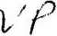
Executed Mav , 2007.
PHEASANT RIDGE DEVELOPMENT, L.L.C.
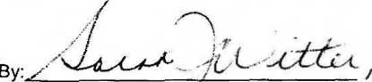
Sarah Witter, Vice-Pw&ident
STATE OF IOWA )
) ss:
COUNTY OF LINN )
This instrument was acknowledged before me on May ///> , 2007, by Sarah Witter, Vice-President of Pheasant Ridge Development, LLC.

'-fHrn lAkAu fyiffritL, __
Notary Public rri and for the State of Iowa
F:\WP\MISC\pheasant ridge dev - bnargale 2nd\briargate second decl.DOC

MARY KAY MOORE COMMISSION #224392 COMMISSION EXPIRES: 7/rt*
.?■: V. •« U* TTiri IQ*- o rn

FOR OVERSIZED DRAWING OF:
EXHIBIT A - BUILDING SITE PLAN
BRIARGATE SECOND, A CONDOMINIUM
LEGAL DESCRIPTION:
LOTS 1,2 AND 3 BRIARGATE SECOND ADDITION IN THE CITY OF MARION, LINN COUNTY, IOWA
FOR OVERSIZED DRAWING OF:
EXHIBIT B-l - SITE SURVEY
BRIARGATE SECOND, A CONDOMINIUM
LEGAL DESCRIPTION:
LOTS 1,2 AND 3 BRIARGATE SECOND ADDITION IN THE CITY OF MARION, LINN COUNTY, IOWA
FOR OVERSIZED DRAWING OF:
EXHIBIT B-2 - SITE SURVEY
BRIARGATE SECOND, A CONDOMINIUM
LEGAL DESCRIPTION:
LOTS 1,2 AND 3 BRIARGATE SECOND ADDITION IN THE CITY OF MARION, LINN COUNTY, IOWA
FOR OVERSIZED DRAWING OF:
EXHIBIT B-3 - SITE SURVEY
BRIARGATE SECOND, A CONDOMINIUM
LEGAL DESCRIPTION:
LOTS 1, 2 AND 3 BRIARGATE SECOND ADDITION IN THE CITY OF MARION, LINN COUNTY, IOWA
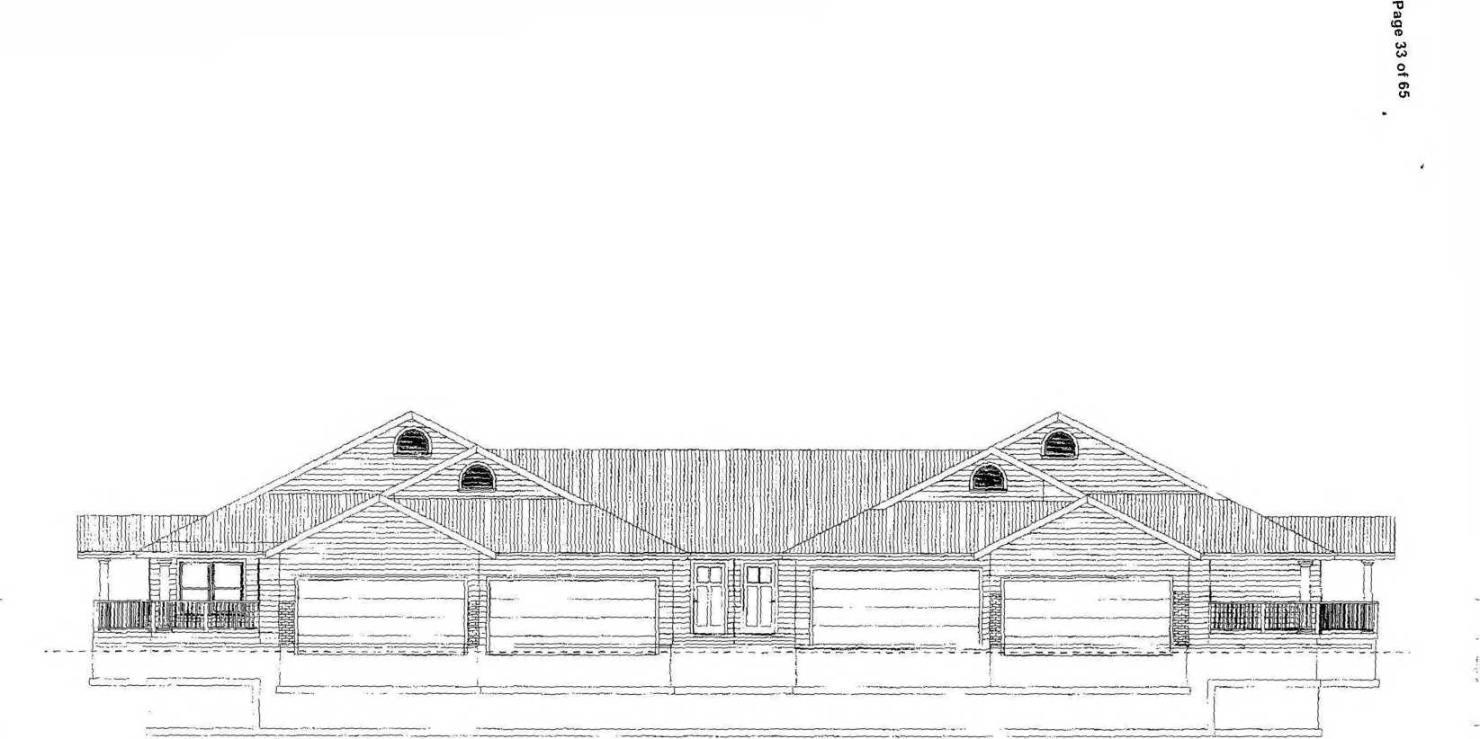
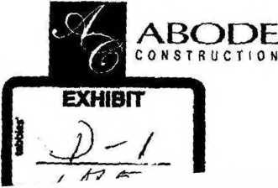
4392 - 4398 SARATOGA DRIVE, MARION, IOWA
BRIARGATE 2nd ADDITION

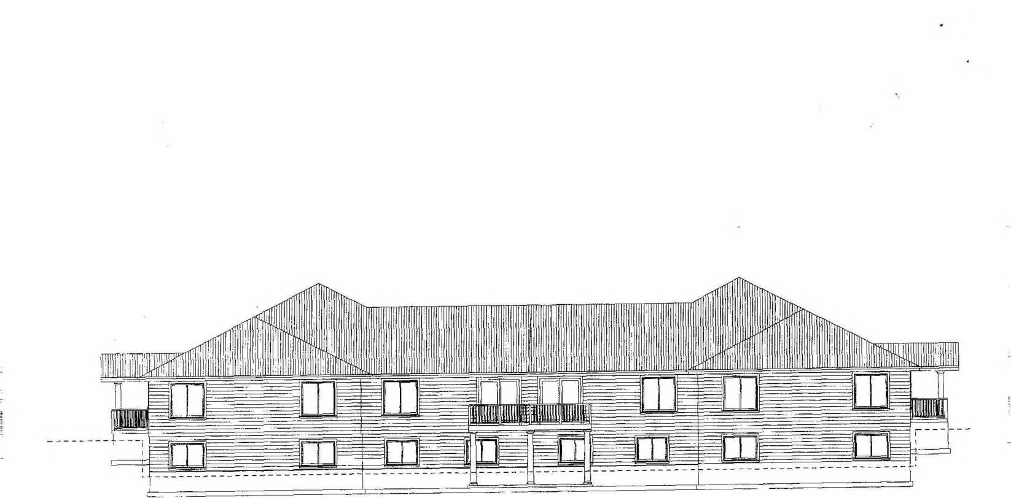
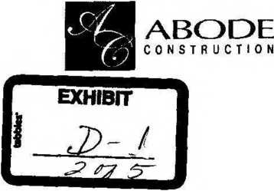
Page 34 of 65

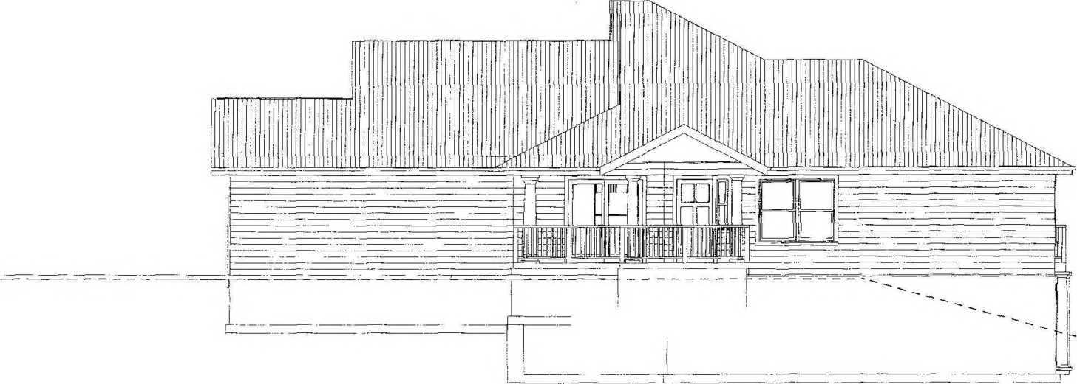
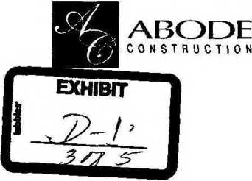
Page 35 of 65
^

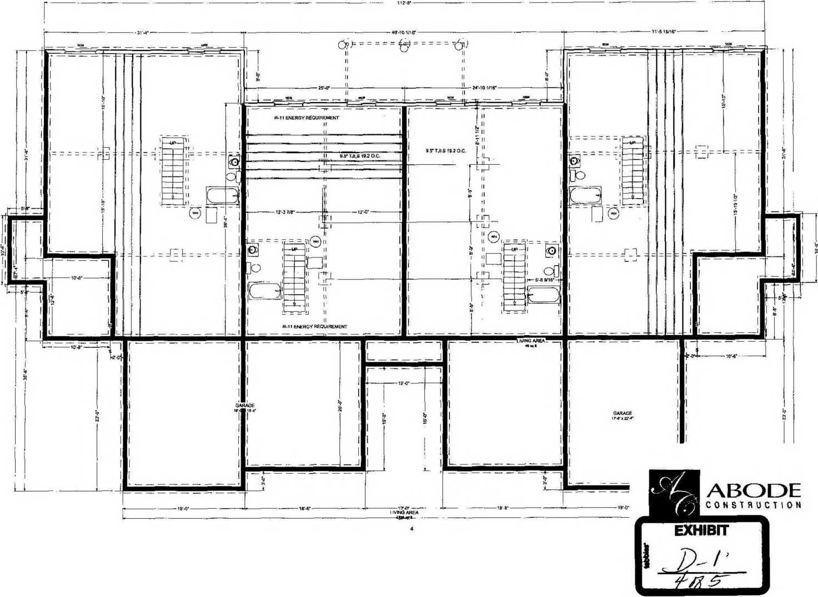
Page 36 of 65

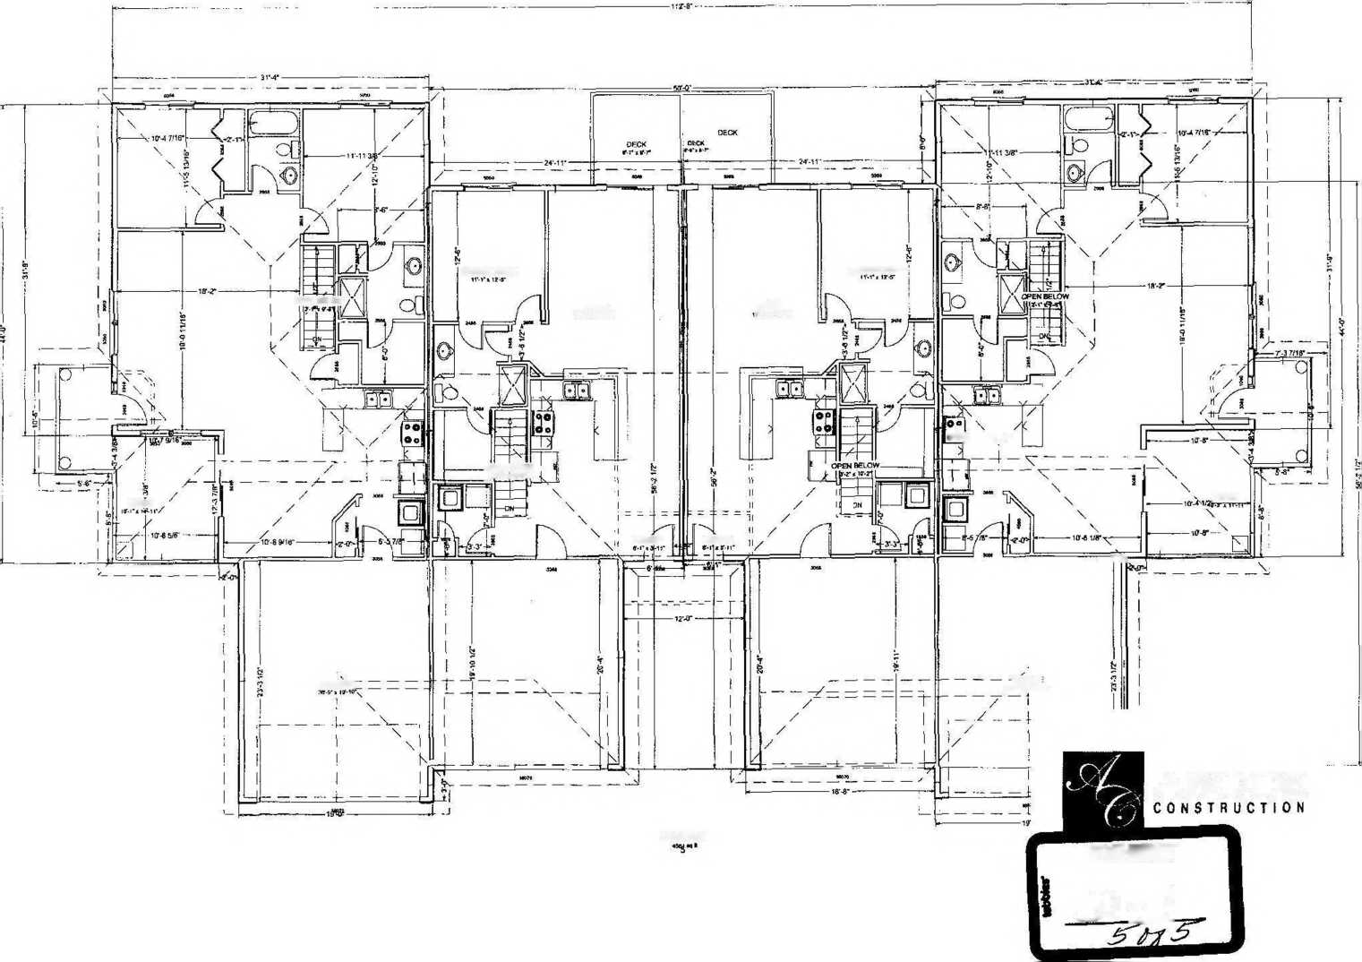
PORCH
OPEN BEI OW
caraGG;
MASTER BDRM
.OPEN BELOW J tr-2' * 10--811
LIVING
w-witMr
lwkq
H-WaIT*
EM TRY
ENTRY
LIVING AREA
MASTER BORM
oO) \/
.PORCH
rh
-GARAGE
/\w.r*zr-r

ABODE
exhibit

J> zJ.
Page 37 of 65

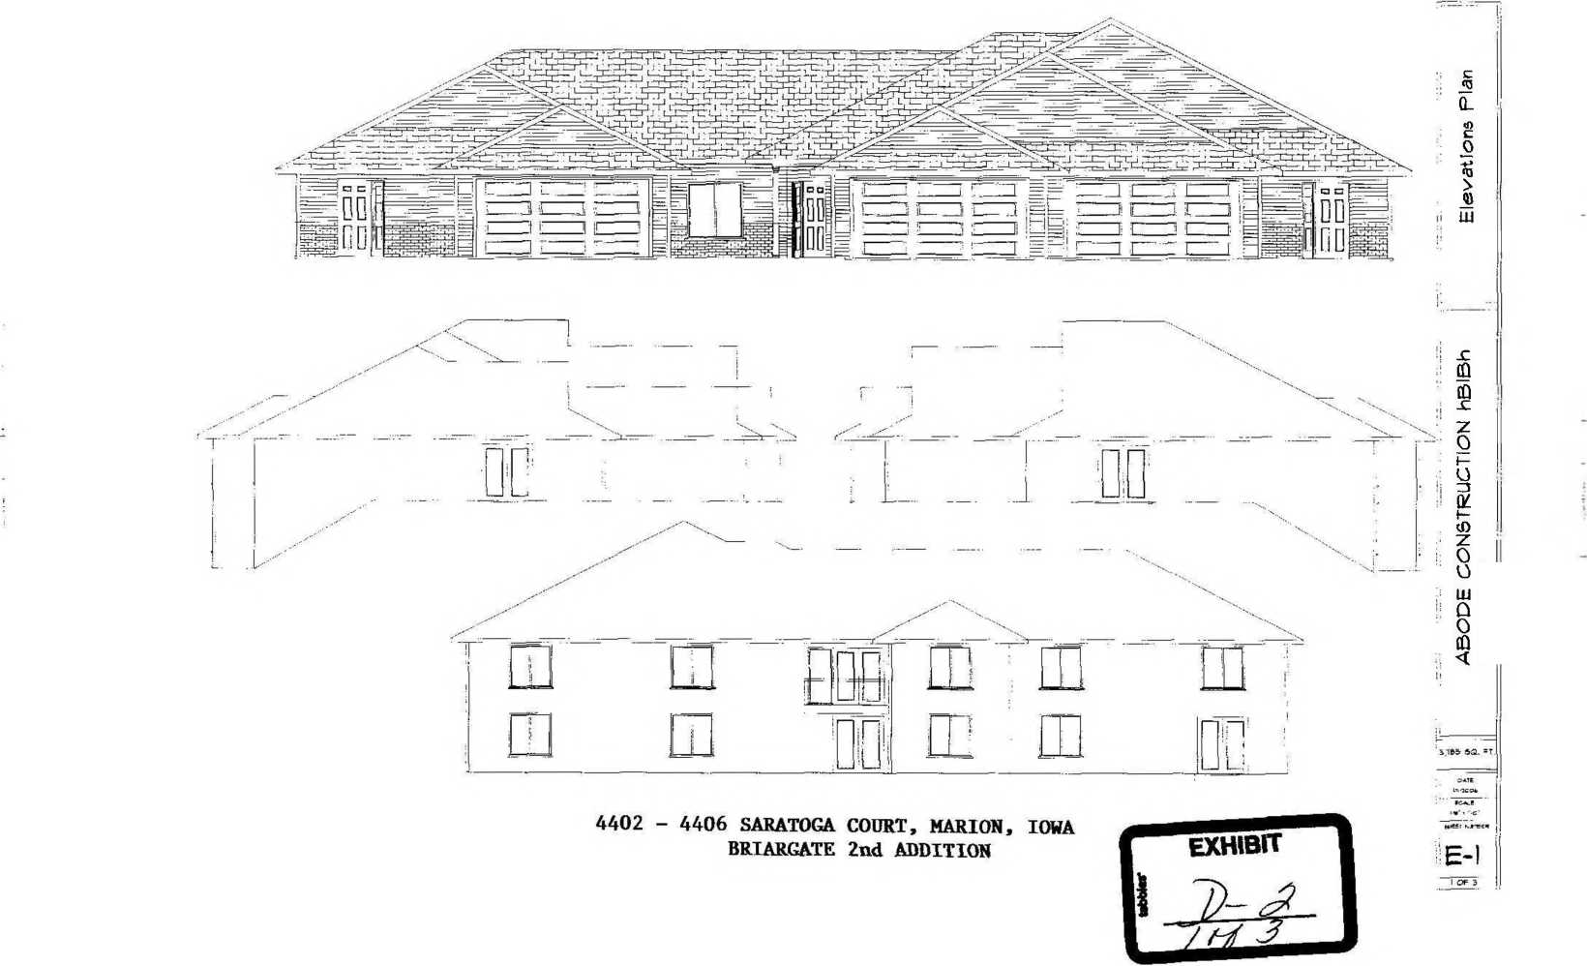
■0
a>
co
to
w
03
o
o>
. U!
>j^n m&ia uo dp=>ipu9hf

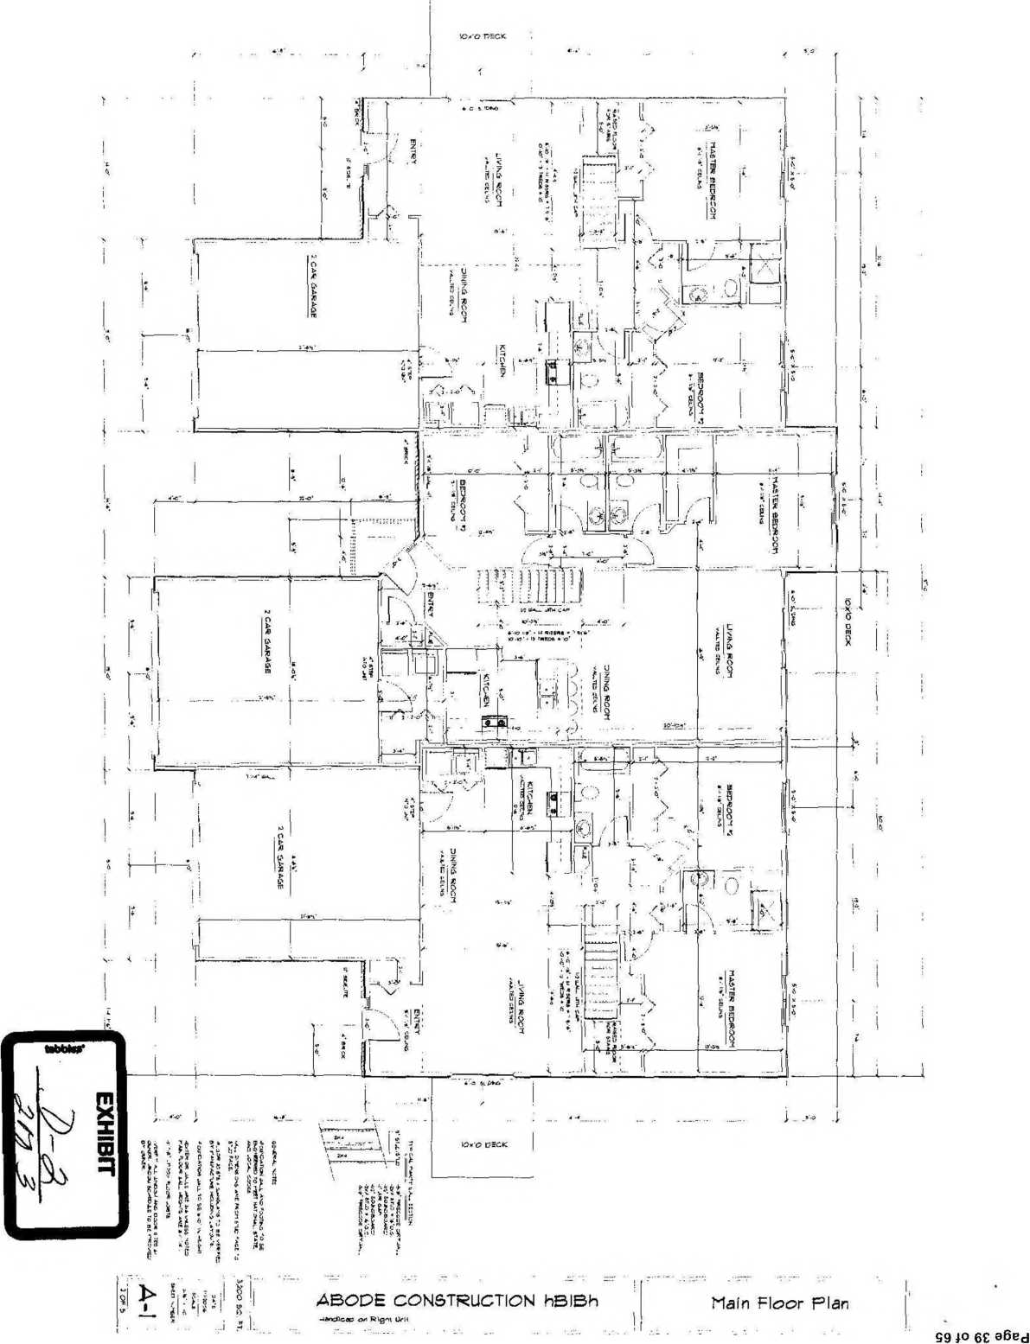

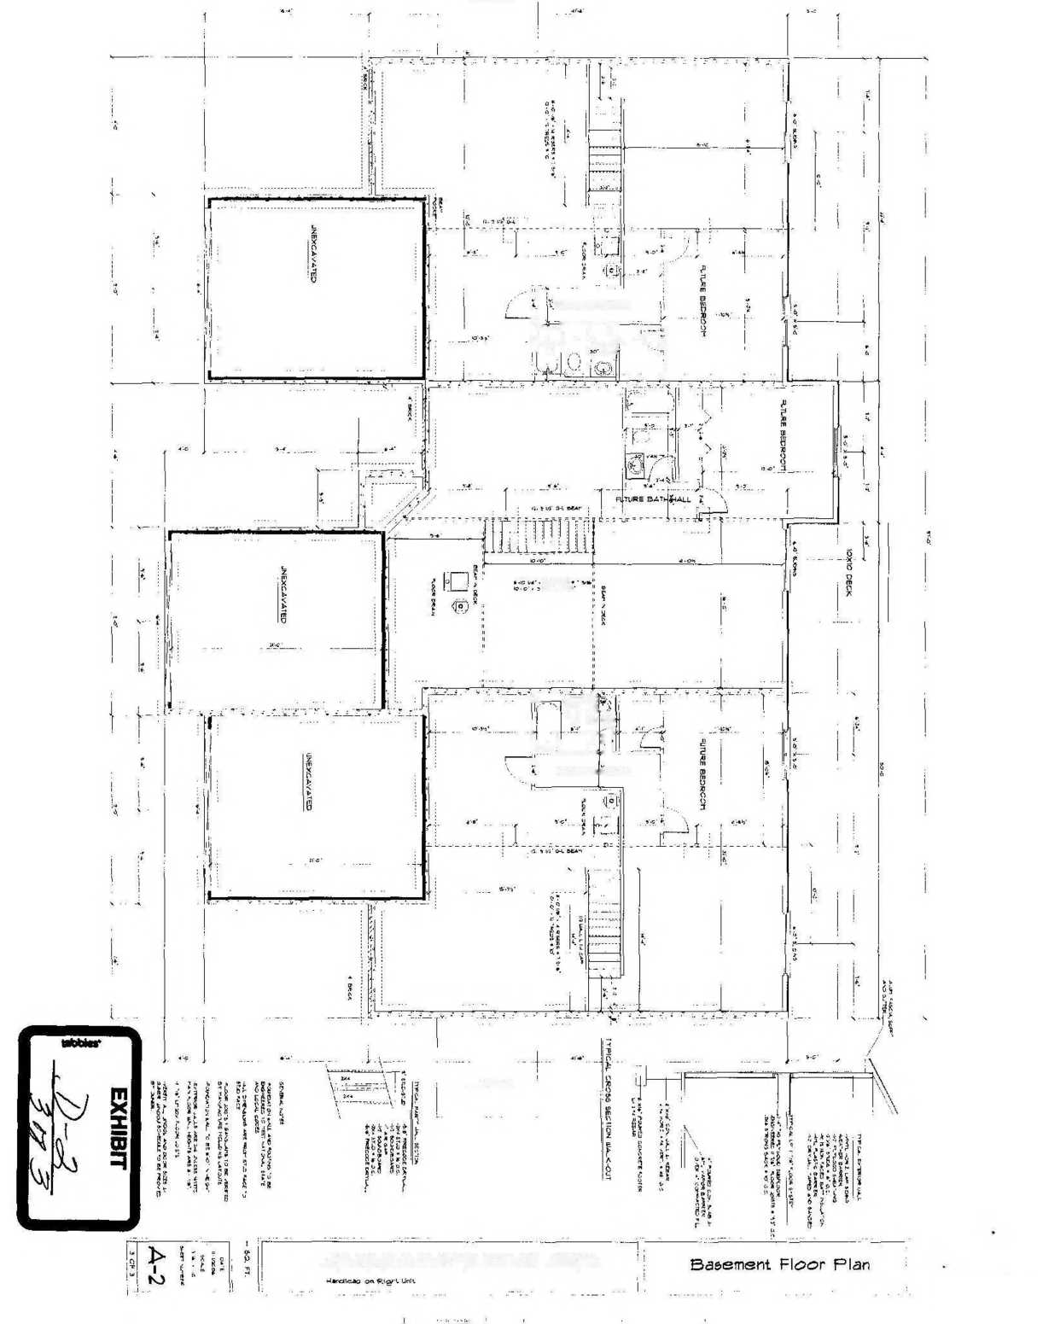
IC*>0 DECK
f-UtURE BATtVMALV,
IfFCJ | »*■ * V. A
 | • ;i

14 *‘SErA TK&t - K
iT | . |."-: i—i. T⁻"
 | W h
 | . I '  v. y sc’ | Ar
i j | 7 | jT
iW'J | - / = | *' 1.
FUTURE DAFH/+4ALL

ABODE CONSTRUCTION hBIBh
S9 io Op 96ed

t
S⁻1—v
A
ro
0
1
a
4*.
ro
oo
CO __ Q> 03 =S
—i JD
® O
to <£
0) 0)
CD O ro g 3 £ Q. 3*

ii

w °
o CJ 3 ll
0
1
-n
—i
o
rn
S
0>
»-►
5'
u
rr

p=q
J

4*:
GO
ro
Ol
CO
cn
Li

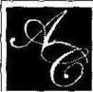
Bldg #5 BRGT2nd Addn f420 - 4428 Saratoga Court, Marion Iowa
DESIGN BY: Abode
Construction
04.10.07
ABODE
CONSTRUCTION
4*M »v* Ut •>
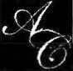
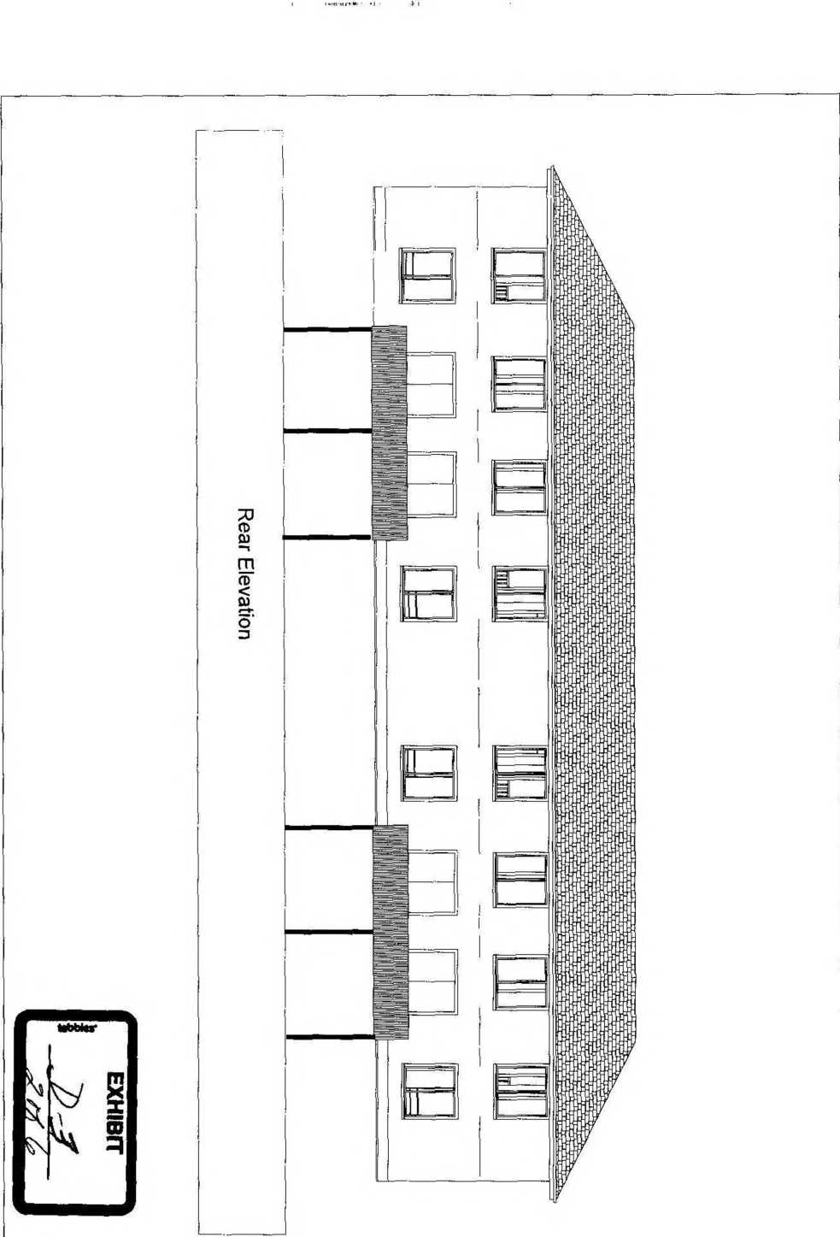
Bldg #5 BRGT2nd Addn jJ420 - 4428 Saratoga Court, Marion Iowa
ABODE
CONSTRUCTION
ho
DESIGN BY: Abode
Construction
04.10.07
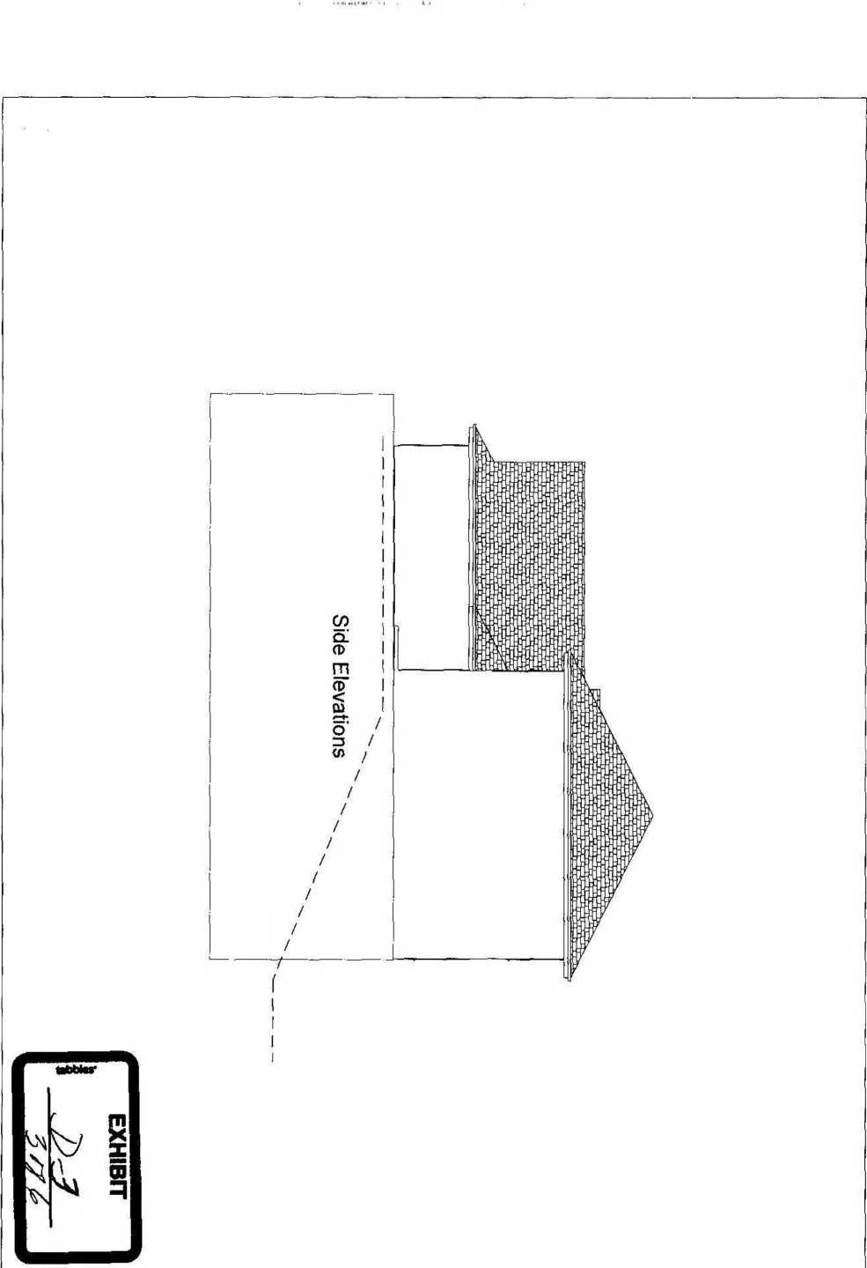
DESIGN BY:
Abode
Construction
04.10.07

Bldg #5 BRGT2nd Addn jt420 - 4428 Saratoga Court, Marion Iowa
ABODE
CONSTRUCTION
9 *0 a6ed

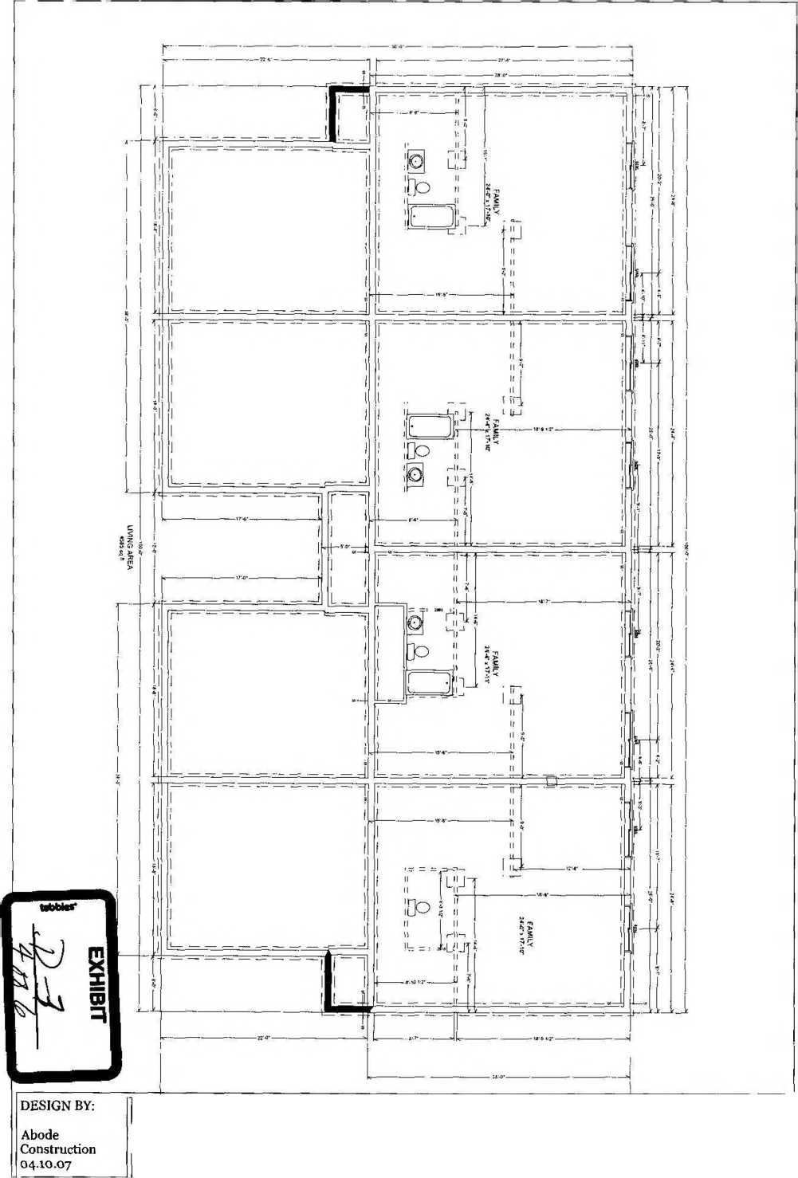
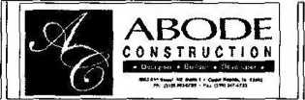
Bldg #5 BRGT2nd Addn f420 - 4428 Saratoga Court, Marion Iowa
-hiOpp a6ed

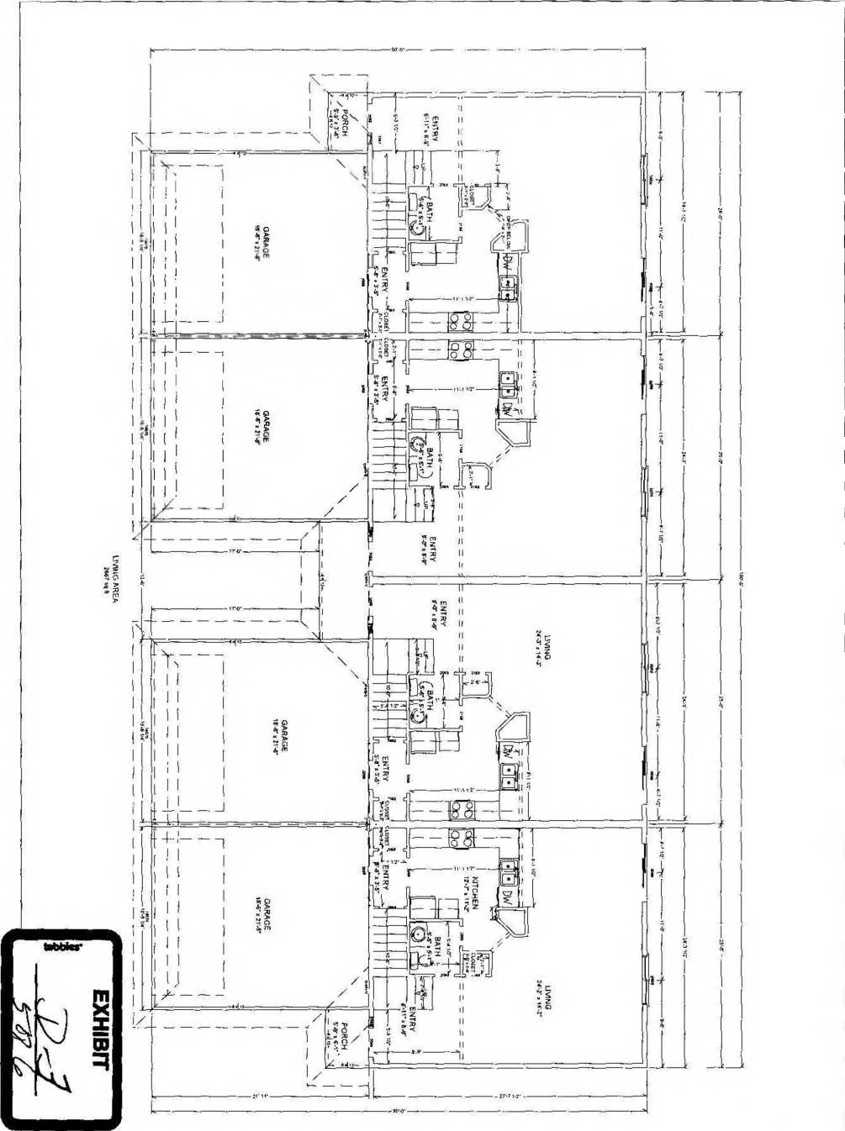
DESIGN BY: | Bldg #5 BRGT2nd Addn [ |  | ' 1
Abode  Construction | 1420 - 4428 Saratoga Court, |  | coYsVmTc T 1 ON j
04.lO.07 | Marion Iowa |  | 1 Hv H ■*•>> •** ■— « • ■ im> . i* 4i<«c  'U«® ** ' *• ^{<r}^ HUfU | l_{t}

S9 *o sp aBed

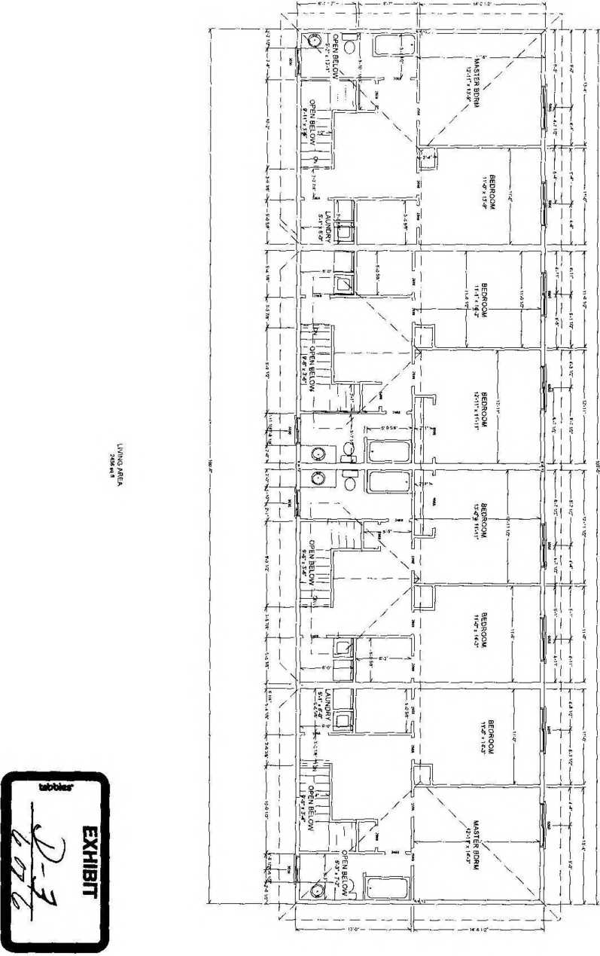

Bldg #5 BRGT2nd Addn jt420 - 4428 Saratoga Court, Marion Iowa
DESIGN BY. Abode
Construction
04.10.07
ABODE
CONSTRUCTION
SURVEYOR’S CERTIFICATE
I hereby certify that the Building Site Plan, identified as Exhibit A and the Site Surveys, identified as Exhibit B-1, Exhibit B-2 and Exhibit B-3 which are attached in this Deciaration of Submission of Property to Horizontal Property Regime for Briargate Seccond, a Condominium, relating to Unit 4392 Saratoga Drive, Unit 4394 Saratoga Drive, Unit 4396 Saratoga Drive, Unit 4398 Saratoga Drive, Unit 4402 Saratoga Court, Unit 4404 Saratoga Court, Unit 4406 Saratoga Court, Unit 4420 Saratoga Court, Unit 4422 Saratoga Court, Unit 4426 Saratoga Court and Unit 4428 Saratoga Court, all in Marion, Iowa, depict and describe, the location and the Buildings, the common area to which each Unit has access and the location of all common elements that afford access to each Unit, all as they now exist as of this date.
I hereby certify that this land surveying document was prepared and the related survey work was performed by me or under my direct personal supervision and that l am a duly licensed land surveyor under the laws of the State of Iowa.
Dated this Z5^day of April, 2007.
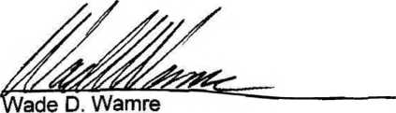
L.S. #17565

EXHIBIT E

Briargate Marion, Iowa
Pheasant Ridge Development, LLC 1853 51st Street NE Suite 1 Cedar Rapids, IA 52402
PROPERTY ADDRESS:
CONTRACTOR / BUILDER:
1 EXCAVATION
Bearing Soil Type: Clay
- FOUNDATIONS
Footings: Concrete Mix 4000 PSI Reinforcing (5) #4-40 Grade
Foundation Wall Material: Concrete
Interior Foundation Wall Material: Concrete
Girder Material and Sizes: (2) 11 -7/8" ML
Sill Material: Construction Grade Green Treated
Insulation: N/A
Additional Information: Typical Spread Footing 8“ D x 16" W
- CHIMNEY (S)
Material: Metal GA. Gl.
Flue Lining Material: GA. Gl.
Water Heater Venting: 3”
- FIREPLACE (S) - (Optional in some units)
(1) Superior 33” GDV or equal
12" Tile Surround on Fireplace w/ Flush Hearth Oak Mantle
- EXTERIOR WALLS
Wood Frame, Wood Grade and Species: 2x6 Hem Fir #2, Corner Bracing
Sheathing: OSB 7/16x4x8 Solid
Siding: Solid Vinyl DBL. 4" Lap Style - Certainteed
Shingles: Certainteed Landmark WWD
Door Sills: Alum w/Oak Adj. Threshold
Window Sills: Wood
Additional information: Gable Wail Const. Same As Main Wails
- FLOOR FRAMING
LPI Floor System: Louisiana Pacific Manufacturer
- SUBFLOORING
Material Grade and Species: OSB VS T & G
Additional Information: Glued and Nailed 8dRS or Cement Coated
- FINISH FLOORING Refer to Item #21
- PARTITION FRAMING Studs: Wood
Grade and Species: Hem Fir #2/ Pine 2x4 16" O.C.
- CEILING FRAMING Engineered Trusses 24” O.C.
- ROOF FRAMING
Engineered Roof Trusses (see truss layouts provided by mfr.)
- ROOFING
Sheathing: Wood, Grade and Species: !4” OSB Solid
Winter Guard as Required by Code; Flashing: 20” Alum. Stand. Gage
Underlay: Asphalt 15# - 30”; Fastening: Staples
EXHIBIT F
13 GUTTERS AND DOWNSPOUTS
Material: Aluminum 5" Typical Gutter
2x3 Downs
Additional Information: Downspout Extensions to Carry Water Away From Structure.
- DRYWALL
Walls: Vi^{m} Sheetrock Ceilings: 5/8” Sheetrock Joint Treatment: Float
Interior Finish: Lt. Orange-peel Texture on Walls, and Acoustic Texture on Ceilings of All Finished Living Areas. Garage Ceiling and Common Wall(s) Between House and Garage to be Hung and Taped to Comply with Local Building Requirements.
- PAINTING - INTERIOR OF HOUSE
Wall and Ceiling Primer: Diamond Vogel Primer
2nd Coat: Diamond Vogel Pro-Build Latex Super Flat -- Color: Mist White Throughout
- INTERIOR DOORS AND TRIM
HC Flush Oak Interior Doors w/OV Jambs
- 1/4" Colonial Oak Casing Bi-fold Doors -HC Flush Oak
- 1/4" Colonial Oak Base Trim
Window Trim: Oak Sill w/ 2 V* oak “skirt” below Stair Parts: Oak Balusters w/ Oak Top Rail Basement Handrail: Oak Wall Mount (Round)
All Interior Millwork to be Pre-finished Oak in Lt. (Honey) Color And 2 Coats Lacquer, Unless Otherwise Noted.
- WINDOWS / PATIO DOORS Silveriine Vinyl - Standard IG (or equal)
- ENTRANCE DOORS AND EXTERIOR DETAIL
Front Entry Door: 3-0 x 6-8, 6-Panel Insulated Steel w/ SL Frame Material: Pine V*
Other Entry Doors: 3-0 x 6-8, 6-Panel Insulated Steel Brick: determined by unit style, Color: Heritage 441 Shutters: determined by unit style
- CABINETS AND INTERIOR DETAIL
Kitchen Cabinets: Mid Continent Woodbury Oak - Honey satin Kitchen Countertop: Standard In-Stock Pf Laminate - See Samples Bath Vanities: Mid Continent Woodbury Oak - Honey satin Bath Countertops: Imperial Molded Tops - White-on-white
- STAIRS
Treads: 1-1/4” Super-tread Material Risers: %" Pine Strings: 2x12 Doug Fir
- FLOORING
Ceramic Tile (front foyer; fireplace, if applicable): 12x12 Esquire; Style: Normandy
Vinyl (kitchen, baths, and laundry): Armstrong Initiator or Mannington Vega II or equal Carpet (L.R., dining, stairs, bedrooms, hallway): Aladdin by Mohawk; Style: China Bay (Gypsy) or equal
- BATHROOM ACCESSORIES
Towel Bars 24”, (1) chrome
18", (1) chrome Recessed Tissue Holders: (2)
Shower Door (ranch-style duplex only): (1) Master Bath - Chrome Frame with Obscure Glass White Shower Rods: (1) - Main Bath
Vanity Mirrors: Y* clear mirror w/seamed edges - Mastic Fastened
- PLUMBING
Water Supply: Public Sewage Disposal: Public House Drain: PVC Water Piping: Copper Tubing
Water heater: A.O. Smith FCG 40 Gal. Natural Gas (or equal)
Gas Piping to Furnace, WH, and Fireplace Gas Service: Utility Company
Kitchen: Dayton #0233224 SS Dbl. Bow! Sink and Delta #400 Chrome
Faucet w/Spray; Badger V Disposal; DW Piping and Hookup, Icemaker Piping
only
Laundry Room. Guy Gray Box for Laundry Hook-Up
Powder Bath (if applicable): Gerber #21-702 White (12" R.l.) Water Closet w/Seat, Reg Bowl Delta #2522-MPU Lavatory Faucet (Chrome)
Master/Main Hail Bath: White Water Closet W/ Reg. Bowl and Seat
Delta #2522-MPU Lavatory Faucet (Chrome)
Cedarglass #60B White 5’ T/S Unit W/Delta #636Chrome Optional Master Bath (ranch-style duplex) White Water Closet W/Reg. Bowl and Seat (2) Delta #2522-MPU Chrome Lavatory Faucet 60” White Fiberglass Tub 36” Shower w/ Delta #636 Chrome Misc.; All Bath Fixtures-White
(1) Frost-Free Lawn Faucet in Garage Full basement bath cast iron rough-in only
24 HEATING / VENTING/ AIR CONDITIONING
Amana 80%+ OR Equal Amana Central AC Unit - 10 Seer (2) Bath Vent Fans Vent Water heater Vent Dryer to Outside
- ELECTRIC WIRING
Service: 200 AMP; Square-D panel/breakers Wiring: Romex
Special Outlet: Range and Dryer Doorbell: Nutone; Push Button Location - Front Door Smoke Detectors: BRK 120V w/Battery Backup Telephone and Cable: Pre-wired-(3) ea.
Switches and Outlets: Per Electrical Diagram & MBD Requirements Pre-wire for OH garage door opener
- LIGHTING FIXTURES
Polished Brass - See Standard Hang-sheet for each style unit
Ceiling Fans w/Lights in L.R. and Master Bedroom (med. Oak/PB or white on white)
- INSULATION
Roof: R-38 Blown-In; Exterior Walls; R-19
Garage Common-Wall Between House and Garage Insulated per Code Requirements Garage Ceiling Blown-In Optional
- MISC.
Appliances: Sears Kenmore refrigerator dishwasher, SC electric range w/hood; microwave optional
Door Hardware: Schlage ‘Plymouth* 605 Pass, Privacy, and Entry Sets
- GARAGES
One or Two-Car Attached With Raised Steel Panel Insulated OH Door (Depending on unit style)
OH Operator(s) and Keypad (s) Optional
- WALKS AND DRIVEWAYS Driveway; Concrete
Front Entry Sidewalk: From Driveway to Front Stoop
- LANDSCAPING, PLANTING, FINISH GRADING
Sod yard; Decorative Rock Under Deck and Along Front Entry Sidewalk

BRIARGATE SECOND, A CONDOMINIUM
Address of Unit 4392 Saratoga Dr.
4394 Saratoga Dr.
4396 Saratoga Dr.
4398 Saratoga Dr.
4402 Saratoga Ct.
4404 Saratoga Ct.
4406 Saratoga Ct.
4420 Saratoga Ct.
4422 Saratoga Ct.
4426 Saratoga Ct.
4428 Saratoga Ct.
Unit Type J
K
Fractional
Interest
1/11
Approximate Area
1/11
K
J
F
F
G
G
1/11
1/11
1/11
1/11
1/11
1/11
1/11
G 1/11
G 1/11
1251sq. ft. main level 1251 sq. ft. lower level 418 sq. ft. garage
891 sq. ft. main level 891 sq. ft. lower level 380 sq. ft. garage
891 sq. ft. main level 891 sq. ft. lower level 380 sq. ft. garage
1251 sq. ft. main level 1251 sq. ft. lower level 418 sq. ft. garage
1251 sq. ft. main level 1251 sq. ft. lower level 418 sq. ft. garage
1260 sq. ft. main level 1260 sq. ft. lower level 418 sq. ft. garage
1251 sq. ft. main level
1251 sq. ft. lower level
418 sq. ft. garage
696 sq. ft. main level 647 sq. ft. upper level 696 sq. ft. lower level 380 sq. ft. garage
696 sq. ft. main level 647 sq. ft. upper level 696 sq. ft. lower level 380 sq. ft. garage
696 sq. ft. main level 647 sq. ft. upper level 696 sq. ft. lower level 380 sq. ft. garage
696 sq. ft. main level 647 sq. ft. upper level 696 sq. ft. lower level 380 sq. ft. garage

ARTICLES OF INCORPORATION OF
BRIARGATE SECOND OWNERS ASSOCIATION, INC.
To the Secretary of State of the State of Iowa .
The undersigned, acting as sole incorporator of a corporation under the Revised Iowa Nonprofit Corporation Act under Chapter 504 of the Iowa Code, adopts the following Articles of Incorporation for such corporation:
ARTICLE I
Name
The name of this corporation is BRIARGATE SECOND OWNERS ASSOCIATION, INC. and it is incorporated under Chapter 504 of the Iowa Code.
ARTICLE II
Purpose and Powers
- The purpose of the corporation is to provide an entity for management of the affairs of and to act as the council of co-owners for that certain horizontal property regime, commonly known as a condominium complex; created and submitted pursuant to the provisions of Chapter 499B, Code of Iowa, known as "Briargate Second, a Condominium" (sometimes referred to as the "Regime").
The corporation shall have all powers and purposes granted or implied to a council of co-owners under the provisions of Chapter 499B, Code of Iowa, and as are granted or implied by the Declaration of Condominium establishing the Regime, and all of such powers shall likewise constitute lawful purposes of the corporation.
- In managing the affairs of the Regime, the corporation may join with the management of any other corporations managing a horizontal property regime in securing or providing services or facilities common in whole or in part to both or all, and in discharging the expense thereof.
- The purposes of the corporation are not for private profit or gain and no part of the corporation's activities shall consist of carrying on political propaganda or otherwise attempting to influence legislation, and the corporation is expressly prohibited from making any distributions of income to its members, directors, or officers, although members, directors, or officers may be reimbursed for expenses incurred while conducting the affairs of the corporation. No dividends shall be paid to members at any time.
EXHIBIT H
ARTICLE III
Registered Office and Agent
The address of the initial registered office of the corporation is 1853 51st Street NE, Cedar Rapids, Iowa 52402 and the name of its initial registered agent at such address is Sarah J. Witter.
ARTICLE IV
Board of Directors
The number of directors constituting the initial board of directors of the corporation is two, and the name and address of the persons who are to serve as the initial directors are:
Jeff Witter Sarah Witter
1853 51st Street NE 1853 51^{8t} Street NE
Cedar Rapids, IA 52402 Cedar Rapids, IA 52402
The initial directors shall not be subject to removal until his term expires as provided in the Bylaws. Thereafter a director may be removed from office at a special meeting of the members of the corporation in such manner as may be provided by the Bylaws.
After the initial board of directors, the board shall consist of such number of directors as shall be fixed and determined by the members from time to time at each annual meeting thereof at which directors are to be elected.
ARTICLE V
Incorporator
The name and address of the incorporator is:
Sarah Witter 1853 51" Street NE Cedar Rapids, IA 52402
ARTICLE VI
Bylaws
The initial Bylaws of the corporation shall be adopted by its initial board of directors; thereafter the power to alter, amend, or repeal the Bylaws or adopt new Bylaws is reserved to the members of the corporation.
ARTICLE VII
Members and Voting
Persons who from time to time own condominium units submitted to the Regime, whether completed or uncompleted, shall be members of the corporation for so long as such persons own condominium units, all of which rights and obligations thereof shall be governed by the provisions of the Bylaws to be adopted as provided in Article VI. The voting rights of the members shall be fixed, limited, enlarged, or denied to the extent specified in the Bylaws.
ARTICLE VIII
Distribution of Assets Upon Liquidation
In the event of liquidation, assets remaining for distribution, if any, shall be distributed to the members in accordance to their proportionate share of the ownership units existing in the condominium Regime, as determined by the Declaration of Condominium and/or the Bylaws which distribution shall not be deemed to be a dividend or distribution of income.
ARTICLE IX
Amendment
Articles VI, VII, and VIII shall be amended only by unanimous vote of all of the members of the corporation. Any other amendment to these Articles may be made as provided in Chapter 504 of the Code of Iowa and amendments thereto, except any in conflict with or contrary to the provisions of the Declaration of Condominium in the form adopted or as later amended submitting lands and Units to the Regime shall be void and of no force and effect.
1/ rA
Executed and dated at Cedar Rapids, Iowa, this day-pf April, 2007.
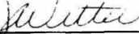
Sarah J. Witter, Incoipbrator 1853 51st Street NE Cedar Rapids, IA 52402
STATE OF IOWA )
) SS!
COUNTY OF LINN )
On this day of April, 2007, before me, the undersigned, a Notary Public in and for the State of Iowa, personally appeared Sarah Witter, to me known to be the person named in and who executed the foregoing Articles of Incorporation and acknowledged that she executed the same as her voluntary act and deed.
NOTARY PUBLIC/ STATE OF IOWA
F:\WP\MlSOpteaaant ridge dev - briargate 2nd\ert inc.DOC
ON EXPIRES: 7/2/02
MARY KAY MOORE COMMISSION #224392
BYLAWS
OF
BR1ARGATE SECOND OWNERS ASSOCIATION, INC.
(A nonprofit Iowa corporation organized
under Chapter 504 Iowa Code)
ARTICLE 1
Scope and Definitions
- The following are Bylaws of Briargate Second Owners Association, Inc., a nonprofit corporation organized under Chapter 504, Code of Iowa, (the “Association”) which govern the council of co-owners of Briargate Second, a condominium regime, situated in Marion, Linn County, Iowa.
- The term "regime” means the horizontal property (condominium) regime known as Briargate Second, a Condominium and situated and located on the following described real estate situated in Linn County, Iowa, to-wit:
Lots 1, 2 and 3, Briargate Second Addition in the City of Marion, Linn
County, Iowa.
As and if additional buildings are submitted to the same regime, this corporation shall likewise function as the council of co-owners of the entire regime as thus supplemented and enlarged.
- The term “person" shall include a corporation, trust or other entity or representative. All references in the plural or singular shall include the other according to context, and all references to gender shall include male, female or neuter according to context.
ARTICLE II
Members and Voting Rights
- Subject to the qualifications set forth in paragraph 2 below, the owners of record of the units lawfully submitted to the regime shall constitute the members of the corporation, and membership shall automatically cease when the record ownership of such unit is terminated. The developer of the regime shall be a member and have the rights of membership with respect to completed but unsold units that have been submitted to the regime.
- If ownership is acquired or terminated by instrument of transfer but not of record, or, if acquired or terminated other than by way of instrument of transfer (such as by death, judicial act or dissolution), the person acquiring or succeeding to ownership shall present the board of directors of the corporation evidence satisfactory to it of facts evidencing lawful ownership status. A fiduciary or other official acting in a representative capacity shall exercise all membership rights and privileges of the owner or property right in respect to which he is serving.
- If more than one person owns an interest in the same unit, all such persons shall be members and remain jointly and severally liable for all membership obligations. In such cases, or if more than one fiduciary or other official is acting in the premises, the votes entitled to be cast by the owners of that unit shall be cast by the person or persons named on a certificate signed by ail owners or fiduciaries or other officials. If such certificate is not executed and filed with the Association, the number of votes entitled to be cast with respect to that unit shall not be counted or voted for purposes of a quorum
EXHIBIT I
or in determining the outcome of any vote unless all owners, or fiduciaries, or officials are present and concur in the casting of such votes. This restriction, however, shall not affect the total number of votes outstanding and entitled to be cast which shall be equal to the number of units in the regime, nor shall it affect any percentage of such total number of votes as is required for any purpose as set forth in any of the condominium documents.
- The total number of votes outstanding and entitled to be cast by all members is equal to the number of units in the regime. The owner of each unit shall be entitled to one (1) vote. If there is more than one owner, the owners shall be entitled to one (1) vote collectively. All votes cast by members collectively shall be cast as one (1) vote and may not be divided.
ARTICLE ill
Membership Meetings
- The annual meeting and any special meeting shall be held within Linn County, Iowa, and all such meetings, annual or special, shall be held at such particular time and place (which may or may not be at the registered office of the corporation), as is set forth in the notice.
- At any annual or special meeting, the presence of members in person or by proxy, who are entitled to cast a majority of the total number of votes outstanding as determined by the Declaration shall constitute a quorum for the transaction of business. All action taken by the members or submitted to them for consideration shall be carried or approved upon the favorable vote of a majority of the votes represented and entitled to be cast at the meeting unless a different rule is provided herein or by the Articles of Incorporation, the Declaration of Condominium, Bylaws or any agreement to which the Association is a party. If neither the president nor vice-president is available to preside, a chairman shall be elected.
- A special meeting of the members may be called by the president or, in the event of his absence or disability, by the vice-president, or by one-third of the directors or by such number of members who are entitled collectively to cast at least twenty-five percent of the total number of votes outstanding and entitled to be cast.
- It shall be the duty of the secretary or his designate to give written notice to members of the time and place of the annual meeting. The person or persons calling a special meeting pursuant to paragraph 3 shall give like written notice of the time and place of such special meeting. All notices shall set forth the purpose or purposes for which the meeting will be held and no action shall be taken at a special meeting which is not directly related to the purposes of the special meeting as defined in said notice.
- At all meetings the order of business shall consist of the following:
- Election of chairman, if required.
- Calling roll and certifying of proxies.
- Proof of notice of meeting or waiver of notice.
- Reading and disposal of any unapproved minutes.
- Reports of officers, if applicable.
- Reports of committees, if applicable.
- Election of inspectors of election, if applicable.
- Election of directors, if applicable.
- Unfinished business.
- New business.
- Adjournment.
Robert’s Rules of Order shall govern unless specifically superseded.
- At all membership meetings, the presence of an owner and the exercise of the voting rights of the owner by proxy shall be permitted and recognized, provided such proxy must be in writing and signed by all persons possessing an ownership interest in the unit in question and shall set forth the period for which the proxy is to be in force and effect. The decision of the board of directors as to the sufficiency of any proxy for recognition shall be final and not subject to appeal to the members.
- Notice shall be given by mailing or delivering the same not less than ten nor more than fifty days prior to the date of the meeting. A mailed notice shall be duly given if addressed to the member at the address of his unit within the condominium regime, unless at the time of giving of such notice, the member has in writing directed a different mailing address to be carried on the rolls of the corporation. If a unit is owned in common or jointly, notice is duly given to the person named in the certificate required by paragraph 3 of Article II.
- The annual meeting of the members shall be held in November of each year, provided the first annual meeting shall not be held until the year 2004. Pursuant to the provisions of the Declaration of Condominium, the developer has retained the right but not the obligation to name all directors until the annual meeting to be held in November, 2004. The provisions of this paragraph shall not inhibit the calling or holding of any special meeting.
ARTICLE IV
Board of Directors
- The corporation and its affairs shall be governed, managed, and administered by a board of directors. The initial board is two in number and the initial Directors shall be Jeff Witter and Sarah Witter. The term of the initial Directors shall be two years or shorter if both initial directors resign prior to the end of their two-year terms. The initial Board need not be members of the corporation. At the expiration of the term of the initial Directors and thereafter, the Board of Directors shall be selected from the members of the corporation. An officer or designated agent of a corporate member may serve as a director.
- From and after the expiration of the term of the initial directors, the Board of Directors shall be three (3) in number. At such time, the full complement of three (3) directors shall be elected. Thereafter the term of office for each director shall be three (3) years, except following the expiration of the term of the initial directors one (1) director shall be elected for a one (1) year term, one (1) director shall be elected for a two (2) year term, and one (1) director shall be elected for a three (3) year term so that at each annual meeting thereafter the terms of office of one-third (1/3) of the Board shall expire and a new director shall be elected accordingly, but there shall be no limitation on the number of terms during which a director may serve. All directors shall serve until their successors are duly designated and qualified.
- Election of directors shall be by ballot in which votes are cast in favor of as many directors as there are vacancies to fill. The person having a majority of the votes cast shall be elected. If no person receives a majority vote, as many additional ballots shall be taken as may be required and in each such case, the nominee receiving the least number of votes in the previous ballots shall be eliminated from further consideration.
- Vacancies in the board of directors may be filled until the date of the next annual meeting by vote of the majority of the directors remaining in office, whether those remaining constitute a quorum or not.
- The initial director shall not be subject to removal. Thereafter a director may be
removed from office at a special meeting called for such purpose if seventy-five percent of the total number of votes outstanding and entitled to be cast are voted in favor of such removal.
- A majority of the board of directors may, by resolution, set a time and place for regular meetings of the board of directors and no notice thereof shall be required until such resolution is rescinded. Special meetings of the directors may be called by the president or any two directors. Not less than two days notice shall be given, personally or by mail, telephone or telegraph, which notice shall state the time, place and purpose of the meeting.
- The board of directors, by resolution approved by all members thereof, may designate from among its membership an executive committee or other committees and by such resolution provide the extent and manner to which the same may have and exercise the authority of the board.
ARTICLE V
Officers
- The officers of the corporation shall be the President, who shall be a director, a Vice-President, who shall be a director, a Treasurer and a Secretary, who may or may not be directors but who must be members, all of whom shall be elected annually by the Board of Directors, except that the initial officers and their successors shall be chosen by the initial Board of Directors, and the initial officers need not be members of the corporation. The Board of Directors may from time to time create and fill other offices and designate the powers and duties. Each officer shall have the powers and duties usually vested in such office, and such authority as is committed to the office by the Bylaws or by specific grant from the Board, but subject at all times to the provisions of the Bylaws and to the control of the Board of Directors. More than one office may be held by a single person.
- The president shall be the chief executive officer of the corporation and shall preside at all membership meetings and shall have power to appoint committees from among the members to assist in the conduct of the affairs of the corporation.
- The vice-president shall preside over membership meetings in the absence or disability of the president, and shall otherwise exercise the powers and duties of the president in the event of the absence or disability of the president, and shall generally assist the president and exercise such other powers and duties as are prescribed by the directors.
- The secretary shall keep the minutes of all proceedings of membership meetings and directors’ meetings and shall have custody and control of the minute book of the corporation, and shall keep or be in charge and control of the records of the corporation except those of the treasurer, and shall give notice where required or directed to do so.
- The treasurer shall have control of the funds and other property of the Association, shall keep the financial books and records thereof and shall pay vouchers approved by the board or designate some person under his or her control to do so.
- Compensation of all officers and employees shall be fixed by the directors. This provision shall not preclude the board of directors from employing a director as an employee, nor from contracting with a director for management of the condominium.
- Any deed or contract for sale of real estate or lease (or assignment of such contract or lease) may be executed by the president or vice-president and any officer other than the president or vice-president. Any lien held by the Association may be released by any of the officers of the Association. The board of directors may, in addition, authorize the execution of the kinds of instruments above mentioned or other instruments required to be executed on behalf of the Association in such manner as it shall by resolution direct
ARTICLE VI
Powers and Duties of the Board of Directors
All of the powers and duties of the corporation (including those existing under the common law and statutes, the Articles of Incorporation, and the documents establishing the Condominium), shall be exercised by the board of directors. Such powers and duties of the directors shall be exercised in accordance with the provisions of the Declaration of Condominium that governs the use of the land, and shall include in addition to those elsewhere provided for, but shall not be limited to, the following:
- To make and collect assessments against members for all common expenses.
- To use the proceeds of assessments in the exercise of its powers and duties.
- The maintenance, repair, replacements, and operation of the condominium property including all common areas, elements and facilities, and units, as applicable and the construction of new improvements or alterations if authorized, and making or providing for payments for all such work and approving or delegating to the treasurer authority to approve vouchers therefor.
- The reconstruction, repair, restoration, or rebuilding of the condominium property and of any units as applicable after casualty or otherwise, as provided in the Declaration.
- To make and amend regulations restricting the use and occupancy of the property in the condominium and in their discretion to permit or forbid an action or conduct as discretion is committed to them in the condominium documents.
- To enforce by legal means the provisions of the condominium documents, the Articles of Incorporation, the Bylaws of the corporation and the regulations for the use of the property in the condominium.
- To contract for management of the condominium and to delegate to such contractor all powers and duties of the corporation except such as are specifically required by the condominium documents to have approval of the board of directors or the membership of the corporation; to employ, designate and remove any personnel necessary for the maintenance, repair and replacement of the common areas and facilities.
- To pay taxes and assessments which are liens against any part of the condominium other than individual units and the appurtenances thereto, and to assess the same against the units subject to such liens.
- To carry insurance for the protection of owners and the Corporation against casualty, liabilities, and other contingencies.
- To pay the cost of all utility or other services rendered to any of the condominium property that is not billed directly to owners.
- To interpret and apply the provisions of the condominium documents in matters of dispute between owners or between owners and the Association, which determination shall be binding on the owners; to conduct or supervise all votes or determinations by members other than a membership meeting.
- To acquire title to and ownership of in the name of the Association units within the regime upon judicial sale, and on behalf of all owners to sell, lease or mortgage such units and to borrow funds for any legitimate purpose and to assign as security therefor the assessment receivables due the Association, provided the board of directors may in no manner affect or encumber the common elements of the regime or any unit or the fractional interest appurtenant to such unit (except such units and the interests appurtenant thereto as the Association has acquired upon judicial sale) and provided further, the authority of the board of directors to borrow in excess of $5,000 other than in connection with the mortgage of an acquired unit to the amount of the loan value thereof shall be exercised only in the event of approval of owners entitled to cast seventy-five percent of the total number of votes outstanding and entitled to be cast. For purposes of permitted conveyance, lease, or encumbrance of units or assessments receivables, the board of directors shall be regarded as the irrevocable agent and attorney in fact for all owners and members.
ARTICLE VII
Common Expenses: Assessments and Collection
- The common expenses of the Association include all those legitimately assumed by it in connection with its powers, duties and obligations as set forth in any of the condominium documents and as are necessary or implied in connection with the powers and duties of the board of directors and the provisions of Chapter 499B and 504A, Code of Iowa. Snow removal and lawn care in connection with common land and the upkeep of the Building exterior shall be assumed by the Association as common expense.
- Assessments against the units and the owners thereof shall be made by the Association in order to provide funds for the discharge of all common expense of the Association, which assessments, in addition to being and constituting a lien against the unit in question and the appurtenances thereto shall also be a personal liability of the owner and jointly and severally if more than one owner. All assessments and funds collected therefrom shall be charged or credited to the owner's account. Unless specifically otherwise provided, as for example in the case of "special" assessments, each unit and owner shall be liable and subjected only to the proportionate share of the total common expense and assessment made therefore as is derived by multiplying the total assessment by the percentage interest of ownership of the common elements which is appurtenant to that unit, as set forth in Exhibit G to the Declaration of Condominium Certain common expense for increased insurance premiums provided by Article VIII, paragraph 9, of these By Laws or on account of the failure of an owner to provide maintenance as provided by Article IX, paragraph 2(c) of the Declaration or other defaults shall be recovered by an assessment made only against a particular unit(s) and the owner or owners, which assessments are referred to in the condominium documents as “special” assessments and shall be made in the necessary amounts and without regard to the percentage of interest formula. The expense of utilities which are not separately metered to each unit is a common expense but the assessments may be made either according to the fractional interest appurtenant to each unit or as “special” assessments on some other shutter
- equitable prorated basis as the Board of Directors may determine.
- Where a mortgagee or purchaser of a unit obtains title as a result of foreclosure of a first mortgage, such mortgagee or purchaser, and his or her successors and assigns, shall not be liable for the assessments chargeable to such unit due prior to the acquisition of title and such unpaid assessment shall be deemed to be common expenses collectible from all owners, including the mortgagee or purchaser, his or her successors and assigns. The owner of a unit pursuant to a voluntary conveyance or by inheritance or devise shall be jointly and severally liable with the grantor or prior owner for all unpaid assessments whether generally or “specially” levied against a unit and the grantor or prior owner, but without prejudice to the right of such grantee or devisee to recover from the prior owner the amounts paid.
A first mortgagee, upon request, shall be entitled to written notification of any default in the performance of the mortgagor of any obligation created by the Declaration of Condominium, the Articles or any other document affecting the condominium, which default is not cured within sixty (60) days.
- The board of directors shall adopt a budget for each fiscal year period as it elects to report on for income tax purposes which shall include the estimated funds required to defray the following common expenses:
- Current expense, which shall include all funds and expenditures to be made within the year for which the funds are budgeted (except expenditures chargeable to reserves or additional improvements), including a reasonable allowance for contingencies and working funds, and the assessment for current expense may sometimes be referred to as the working capital assessment and the funds as the working capital fund. Any balance in this fund at the end of each year may be applied to reduce the assessments for current expense for the succeeding year.
- Reserve for deferred maintenance, which shall include funds for maintenance items which occur less frequently than annually and for replacement of common property required on account of depreciation or obsolescence.
- Reserve for replacement, which shall include generally funds for repair, reconstruction and the like required because of damage, destruction or other hazards.
Upon the determination of each budget, the directors shall each year levy an assessment for the amount assessed against each unit at least thirty days prior to the one year period covered by the budget and assessments. Notwithstanding the foregoing requirement of regular assessments, the board of directors may discontinue a regular annual assessment or reserve for replacement, or transfer such portion to another fund or account if in its judgment the amount remaining is sufficient to satisfy the best interests of the members.
- The board may also make and levy, from time to time, assessments for common emergency or extraordinary expenses. Emergency assessments and “special" assessments shall be due and payable according to the terms fixed by the board. Funds for emergency expenses may be raised by emergency assessment and/or by regular but separate reserve accounts and assessments for such purposes.
- The regular annual assessments made for current expense and deferred maintenance and replacement reserves or for any other purpose shall be due from and paid by the unit owners as to their shares thereof in twelve equal monthly installments payable on the first day of each month during the one year period in question. If any installment of any assessment of any kind or character is in default for more than thirty days, the board of directors may accelerate the remaining installments and declare the entire amount thereof due and payable within twenty days after written notice thereof is mailed to the owner in default at his address carried upon the corporate records. When the Association has acquired a unit, the assessment otherwise due and payable, reduced by the amount of income which may be derived from the leasing of such unit by the Association, shall be apportioned and assessments for the unit levied ratably among all other owners according to their percentage interests in the common elements.
- At the time of the recording of the Declaration of Condominium or when the certificate of occupancy for a building has been issued or as the board of directors determines, in its discretion, that a building and improvements have been substantially completed and are ready for occupancy, the board of directors shall immediately meet and adopt an interim budget and make such assessments of whatever character as are necessary in order to provide for the expenses and obligations of the Association as determined by the condominium documents during the period of any fractional
calendar year or any fractional fiscal year as may remain until the commencement of the initial one year period contemplated by paragraph 4 of this Article, which assessments shall be effective as of the date of the certificate of occupancy or such determination made by the board.
- If prior to the date of its first annual meeting the Association requires capital, the Developer may loan to it any sums required in excess of the assessments for which the Developer is liable as a unit owner, in which event the requirement of Article VI, paragraph 12, of approval by a seventy-five percent vote shall not apply.
- The share of all sums assessed to and payable by an owner but unpaid shall constitute a lien on the unit or of such owner prior to ail other liens, except tax liens on the unit in favor of any assessing unit or special district and all sums payable on a first mortgage of record, which lien may be foreclosed by the Association in the manner and with the consequences provided in Section 499B.17, Code of Iowa. In event of foreclosure the owner shall be required to pay a reasonable rental for the unit if he or she remains in possession. The Association may sue for money judgment for unpaid assessments or sums due without foreclosing or waiving any lien which it holds. In event of suit or foreclosure, the Association shall be entitled to collect reasonable attorney fees from owner.
- The Association shall at all times maintain complete and accurate written records of each unit owner and the address of each, and setting forth the status of all assessments, accounts and funds pertinent to that unit owner. Any person other than an owner may rely on a certificate made from such records by an officer or agent of the Association as to the status of all assessments and accounts.
- Notwithstanding anything to the contrary in these Bylaws, any regular annual assessment or common emergency or extraordinary expense assessment may not be increased by more than Fifty Dollars ($50) per month without the approval of the members at a special or annual meeting by a vote provided for in Article III, paragraph 2.
ARTICLE VIII
Taxes
- Real Estate Taxes. Real estate taxes assessed against the regime shall be assessed against the individual units by the assessing authorities and shall be paid by the unit owners. Each owner’s assessment shall include the owner’s fractional share of the common elements as set forth in the Declaration. Each unit owner when assessed shall be liable to pay all of such taxes assessed and the Association shall have no responsibilities to pay the same but may do so as provided in Article VI, paragraph 8, of these Bylaws.
- Personal Taxes. If any personal taxes are assessed against an owner, such owner shall be solely responsible for the payment of the taxes. If any personal taxes are assessed against the Association, such taxes shall be paid by the Association as a part of the Association’s common expenses.
ARTICLE IX
Referendum
Any vote or determination required or permitted to be made by the members of the Association and not required by law or any of the condominium documents to be made at a meeting of the members may be taken or made pursuant to a referendum ballot. Such a ballot may be initiated by one-third (1/3) of the board of directors or upon the written petition of owners who are entitled collectively to cast at least twenty-five percent of the total number of votes outstanding. If such referendum is initiated, the secretary shall prepare and mail to each member a ballot returnable in no less than ten nor more than fifty days from the date of mailing. If prior or subsequent to such petition a special membership meeting has been called to consider the same subject matter, the special meeting shall prevail and the referendum vote shall not be tallied.
ARTICLE X
Amendment
- Except as provided in these Bylaws, these Bylaws may be amended, altered, repealed or new Bylaws adopted by the members at a special or annual meeting of or upon a referendum ballot by the members upon the affirmative vote of seventy-five percent of the total number of votes outstanding and entitled to be cast, all in accordance with the declaration and these Bylaws. No amendment, alteration or action taken to repeal these Bylaws and adopt new Bylaws shall change the provisions of the Declaration and these Bylaws which equate membership with unit ownership, define the total number of votes, and base for each unit the number of votes, liabilities for assessments, and interests in funds including insurance proceeds of the Association on the fractional interest appurtenant to that unit unless unanimous consent of the unit owners and their mortgagees is secured. Any amendment, alteration or action taken to repeal these Bylaws and adopt new Bylaws which affect Developer’s rights, shall be void unless the written consent of Developer is given.
- No amendment may be adopted at either a special or regular membership meeting not included in the notice of the meeting; provided, however, if notice of the proposed amendment has been given, a different amendment relative to the subject matter of the notice may be adopted by those present, in person or by proxy, and possessing the requisite percentage of the total number of votes outstanding and entitled to be cast, and provided further, no vote by proxy may be counted unless the proxy expressly provides for such contingency. More than one proposed amendment may be included in the notice of a meeting.
- To the extent provided in Section 499B.14, Code of Iowa, no modification or amendment of these Bylaws shall be effective unless set forth in an amendment to the Declaration executed and recorded in the manner set forth in the Declaration and that code section, and an amendment to these Bylaws shall constitute an amendment to the Declaration as provided for by law.
- Unless required by the specific provisions of the condominium documents or by law, an amendment to the Declaration not affecting the subject mater of these Bylaws shall not be considered an amendment of these Bylaws.
ARTICLE XI
Indemnification of Directors and Officers
The corporation shall indemnify any director or officers of the corporation, any former director or officer and any such person who at the request of the corporation is serving or has served as a director, officer, employee, agent or trustee of another corporation, partnership, joint venture, trust or other enterprise, and their heirs, executors and administrators, against all expense, liability and loss (including attorneys' fees, judgments, fines, taxes, penalties, and amounts paid in settlement) actually and reasonably incurred by the Indemnitee as to action in the person’s official capacity and as to action in another capacity while holding office if the person acted in good faith and in a manner reasonably believed by the person to be in or not opposed to the best interest of the corporation, and, with respect to any criminal action or proceeding, the person had no reasonable cause to believe the person’s conduct was unlawful. The indemnification shall include but not be limited to the amount of funding for reserve accounts, pursuing remedies for the collection of unpaid assessment and determining the extent of maintenance, repair, replacements and operation of the condominium property. The indemnification shall exclude any directors’ and officers’ acts for gross negligence or willful misconduct in the performance of their duties to the corporation unless and only to the extent that a court in which such action or suit was brought shall determine upon application that, despite the adjudication of liability but in view of ail circumstances of the case, the officer or director is fairly and reasonably entitled to indemnity for such expenses which such court shall deem proper. The obligation of the corporation under this Article shall be subject to the terms and conditions of a plan of indemnification adopted by a majority of the board of directors. Any such plan may limit or condition the obligation of the corporation, may grant contract rights to indemnitees, may limit indemnification to persons serving in specified offices, may provide procedural and substantive rights to indemnitees and may be amended, modified or terminated by a majority of the board of directors. A plan of indemnification may obligate the corporation to indemnification which is less than the full extent permitted by applicable law and may contemplate future change in applicable law.
Indemnification under this Article shall be applicable to all actions regardless of the date or dates of any alleged transactions or occurrences giving rise to such actions unless the plan of indemnification provides to the contrary. No amendment, modification or termination of a plan of indemnification shall affect any right of indemnification arising out of a transaction or occurrence entered into or occurring prior to the effective date of such change in the plan. In the event the board of directors terminates a plan of indemnification without adopting another plan, indemnification under this Article shall be to the full extent allowed by applicable law until another plan has been adopted by the board of directors.
Indemnification under this Article or a plan of indemnification shall not restrict the power of the corporation to provide for indemnification in any other manner and shall not obligate the corporation to acquire and maintain insurance or to otherwise provide funds to meet its obligations.
ARTICLE XII
ARBITRATION
Any dispute, controversy or disagreement under this Declaration or the By-laws of the Association shall be resolved by arbitration to be conducted by and under the rules of the American Arbitration Association, to be held in Linn County, Iowa. Arbitration shall be commenced within 14 days from the date that there is no agreement between a member and the Association by the aggrieved member sending written notice to the Association at its registered office or to a director of the Association at the director's last known address. The mailing of such notice by registered or certified mail shall commence the arbitration proceedings and any award or decision in arbitration shall be binding upon the parties as provided in Chapter 679A of the Iowa Code. The arbitration award or decision may be entered as a judgment in the Iowa District Court in and for Linn County as provided in Chapter 679A of the Iowa Code. The arbitrator does not have authority to amend the Declaration, the Articles of Incorporation or the By-Laws of the Association. The expenses of arbitration shall be borne by the Association.
ARTICLE XUl
General Provisions
- The invalidity of any portion or provision of these Bylaws shall not affect the validity of the remaining provisions or portions hereof.
- The corporation shall not have a corporate seal.
- The Board of Directors may require fidelity bonds from all directors, officers or agents handling or responsible for Association funds, except any insurance trustee, and shall procure an
audit of the accounts and financial records of the Association not less than every two (2) years, and the expense of such matter shall be a common expense of the Association.
- Each member shall have the obligations as such member as are imposed upon him or her by the condominium documents as an owner, and no member shall have any power or authority to incur a mechanic’s lien or other lien effective against the condominium property, except as the same may attach only against his or her appurtenant interest and be removable as such.
- The board of directors may, in its discretion, issue written evidence of membership, but the same shall be evidence of membership only and shall in no manner be transferable or negotiable, and the share of the member in the assets of the Association cannot be assigned, hypothecated or transferred in any manner except as an appurtenance to such assignment, hypothecation, or transfer of the unit.
- So iong as a unit is owned by Developer, Developer shall only be subject to assessment for “current" expense. Upon acquisition of such a unit from Developer, however, such unit shall then be subject to assessment for “reserves” for a prorated balance during the fiscal year in question and the payment in the same amount as previously assessed against the unit not owned by Developer and to assessment and, in addition, the lien for any emergency assessments in the same manner as if
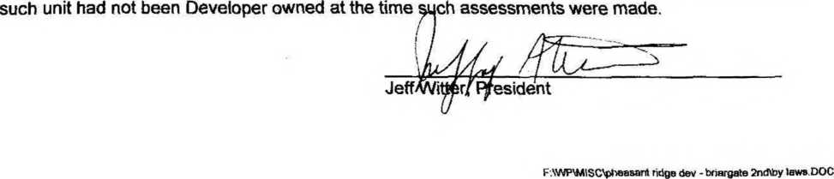

Effective Date of Fractional Interest
Possession of Common Elements
Partition
Severability
Articles of Incorporation and Bylaws of Association
Chapters 499B and 504 of the Code of Iowa
Captions
Severability ARTICLE XV - FIRST LIEN HOLDERS RIGHTS - Notices of Action - Other Provisions for First Lien Holders u

